 | Patient details
Patient Name
Address
DOB |  |  |  | NHS No.
Home Tel. No. |  |  |  | Gender
Mobile Tel. No. |  |  |  | Ethnicity
Preferred Tel. No. |  |  |  | Email Address
Main Spoken Language |  |  |  | Interpreter needed? | Yes | No
Transport needed?
 | Hearing Impairment  Learning disability |  |  | Visual impairment  Dementia
Communication requirements | Communication difficulties other: (please specify)  Does the patient require any special assistance on attending appointments (eg hoist)? Yes No  If yes, please provide details:
Safeguarding concerns?
Date of Decision to Refer

 | Registered GP details
Practice Name
Registered GP |  | Usual GP / Referring  GP
Registered GP Address
Email |  | Practice Code

Patient engagement
The patient has been informed that the reason for referral is to rule out or rule in Cancer.
Supporting information (leaflet) provided
The patient has been informed of the likely next pathway steps and the time in which they should be contacted?
The patient has confirmed that they are willing and available to be contacted and attend the hospital for appointments and tests within the required timeframes?)
Referral criteria
NICE guideline / Reference number:NG12 Published: 23 June 2015 / Last updated:15 April 2026
Ovarian cancer | Physical examination identifies ascites and/or a pelvic or abdominal mass that is not obviously uterine fibroids.
Ovarian cancer | Ultrasound scan of the abdomen and pelvis suggests ovarian cancer.
Ovarian cancer | Raised CA125 alone is not a referral criterion. Follow the age-specific NICE primary-care CA125/ultrasound pathway below; refer if ultrasound suggests ovarian cancer.
Endometrial cancer | Age 55 and over: unexplained postmenopausal bleeding that cannot be attributed to HRT.  Age 55 and over. Ultrasound findings indicate suspicion of endometrial cancer (see Information for primary care below for criteria for suspected cancer direct-access ultrasound in this age group)  Age under 55: consider suspected cancer pathway referral for unexplained postmenopausal bleeding that cannot be attributed to HRT.  Unscheduled bleeding on HRT: follow current British Menopause Society guidance (see flowchart , page 6). USCP referral is indicated with 1 major or 3 minor endometrial cancer risk factors, or following abnormal TVS requiring endometrial assessment.
Cervical cancer | Consider suspected cancer pathway referral if, on examination, the appearance of the cervix is consistent with cervical cancer.  Local pathway advice: cervical ectropion and uncomplicated cervical polyps should not be referred via the suspected cancer pathway unless the cervical appearance is suspicious for cancer.
Vulval / vaginal cancer | Vulval: consider suspected cancer pathway referral for an unexplained vulval lump, ulceration or bleeding.  Vaginal: consider suspected cancer pathway referral for an unexplained palpable mass in or at the entrance to the vagina.
If the patient does not meet NICE suspected cancer referral criteria but there remains significant clinical concern, please provide full details in the referral letter. Local pathway criteria may also apply.

Referral letter
(please include any symptoms and examination findings)

Relevant investigations

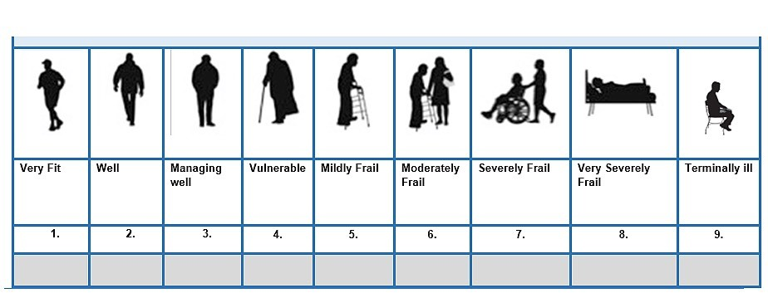

P
l
e
a
se

t
i
ck

p
a
t
i
e
n
t
’
s

R
o
ck
w
o
o
d

c
l
i
n
i
c
a
l

f
r
a
il
t
y

sc
o
r
e
Information for primary care
Ovarian cancer | NICE NG12 (updated April 2026)  Symptoms suggesting ovarian cancer include persistent/frequent (particularly >12 times/month) abdominal distension/bloating, early satiety or loss of appetite, pelvic/abdominal pain, and urinary urgency/frequency. Also consider testing with unexplained weight loss, fatigue or change in bowel habit. In people aged 50 or over, new IBS-type symptoms within the last 12 months warrant ovarian cancer testing.  Referral / investigation pathway:  • Ascites and/or a pelvic or abdominal mass on examination (not obviously uterine fibroids): refer directly on a suspected cancer pathway.  • Age 39 or under with persistent, suggestive symptoms: do not use CA125 in isolation; consider urgent direct-access ultrasound of abdomen and pelvis.  • Age 40 or over with persistent, suggestive symptoms: measure CA125 in primary care. Arrange urgent direct-access ultrasound (within 2 weeks) when CA125 is at or above the age-specific threshold:  • If ultrasound suggests ovarian cancer: refer on a suspected cancer pathway.  • If CA125 is below the age-specific threshold, or meets the threshold but ultrasound is normal: investigate other potential causes of symptoms as appropriate. If no other cause is identified, advise the patient to return for reassessment if symptoms persist, become more frequent or worsen.
  Age | CA125 threshold (IU/mL)
  40–49 | ≥35
  50–59 | ≥31
  60–69 | ≥24
  70–79 | ≥25
  80+ | ≥31
Endometrial cancer | NICE NG12 (updated April 2026)  • Age 55 and over: refer for unexplained postmenopausal bleeding that cannot be attributed to HRT.  • Age under 55: consider suspected cancer pathway referral for unexplained postmenopausal bleeding that cannot be attributed to HRT.  • Age 55 and over: consider suspected cancer direct-access ultrasound for:  - unexplained vaginal discharge and are:  - presenting with these symptoms for the first time; or  - have thrombocytosis; or  - report haematuria; or  - visible haematuria and:  - low haemoglobin levels; or  - thrombocytosis; or  - high blood glucose levels.  • Unscheduled bleeding on HRT: NICE signposts to British Menopause Society guidance. Follow the current BMS pathway/flowchart below (reviewed May 2026).
Cervical cancer | NICE: consider suspected cancer pathway referral if the appearance of the cervix is consistent with cervical cancer.  Local pathway advice: cervical ectropion and uncomplicated cervical polyps should not be referred via this pathway unless the cervical appearance is suspicious for cancer; use the appropriate routine gynaecology pathway if assessment is required.
Vulval / vaginal cancer | Vulval – NICE: consider suspected cancer pathway referral for an unexplained vulval lump, ulceration or bleeding.  Local advice: persistent/worsening vulval disease, including lichen sclerosus, should be assessed according to clinical findings; use this pathway if there is a suspicious focal lesion, lump, ulceration or bleeding.  Vaginal – NICE: consider suspected cancer pathway referral for an unexplained palpable mass in or at the entrance to the vagina.

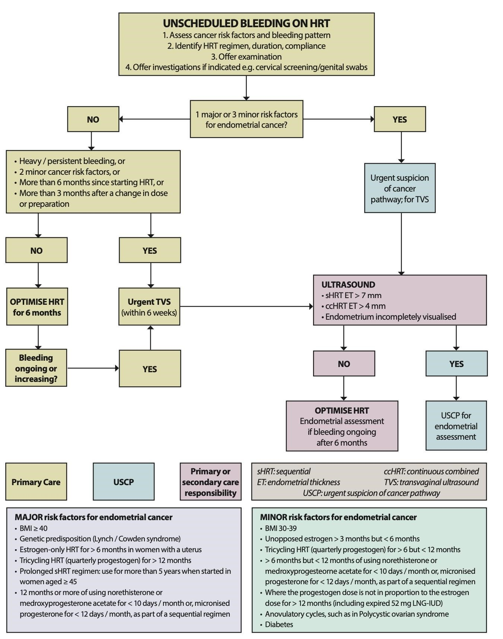
Guidance basis: NICE NG12 Suspected cancer: recognition and referral (last updated 15 April 2026); British Menopause Society joint guideline on unscheduled bleeding on HRT (reviewed May 2026).

