Referral Urgency and Response Times for the Integrated Nursing and Conditions Service –
Community Nursing and Out of Hours Nursing Service

Care Coordination Reference No:
Integrated Nursing & Conditions Reference No: | CCH - 5
Version: | 1.5
Author: | Angela Hind – Clinical Project Lead (INCS)  Alex Webster – Service Manager (Care Coordination and Customer Care)
Second Author
First Issued On: | 27th June 2023
Latest Issue Date: | September 2024
Review Date: | September 2026
Referenced Documents: | Ref 1246 Referral and Call Management for INCS Process Guidance
Ratified By: | Care Coordination and Community Nursing Group
Distribution: | Team Huddles / meetings and staff supervision

Document Revisions
Date | Author | Nature of Change | Reference
13/07/23 | Angela Hind | Addition of Symptomatic Bowel cancer Two Week Wait Pathway | Section 4.2 & 4.4
07/09/23 | Angela Hind | Amendment to wording Re: requests for Annual / QOF Phlebotomy & BP requests and Ear Syringe for Hull Treatment Room Patients only | Section 4.3
28/11/23 | Angela Hind | Addition of Skin Tears | Section 4.5
09/04/24 | Angela Hind | Title amended to include OOHNS Housebound service offer only  Amendment to wording of response times  Amendment to prioritisation for Skin Tears in Care Homes  Addition of Hull Consumables Process | Whole Document  Section 4.2  Section 4.2 & Section 4.5

This document can be found on MyCompliance and CHCPs U: Folders
Please make sure you use the most current version.

CONTENTS
Section | Title | Page
1. INTRODUCTION 2
2. PURPOSE 3
3. SCOPE 3
4. PROCESS 4
4.1 Referral in Flow Chart Guide 4
4.2 Referral Urgency and Response Times 4
4.3 Referral Criteria and Response Times for Phlebotomy and Blood Pressure Recording Requests for all Housebound Patients 8
4.4 Symptomatic Bowel Cancer Two Week Wait Pathway 9
5. DISSEMINATION, IMPLEMENTATION AND ACCESS 12
6. APPROVAL 12
7. MONITORING AND COMPLIANCE 12

INTRODUCTION
This document provides guidance to the interventions and care provided by the Integrated Nursing and Conditions Service and the response times for each specific request for housebound patients.

Care Coordination and Clinical staff should always use their personal and professional judgement based on the information they are presented with at the time of contact. If there is any doubt the request / referral should be accepted and then escalated appropriately.

The response times are to be used as a guide and each request will be individually clinically triaged and a visit arranged accordingly. It should also be noted that there may be occasions when it is difficult to achieve the desired response time e.g. during the Out of Hours Period.

PURPOSE
The purpose of this document is to provide guidance to the urgency and response times required when processing requests / referrals for the relevant Integrated Nursing and Conditions Service team.

SCOPE
This guidance relates to the following teams:
Care Coordination Hub (CCH): | Clinical Team:
Care Coordination Hub (247111) | Community Nursing
 | Out Of Hours Nursing Service

PROCESS

4.1 Referral in Flow Chart Guide
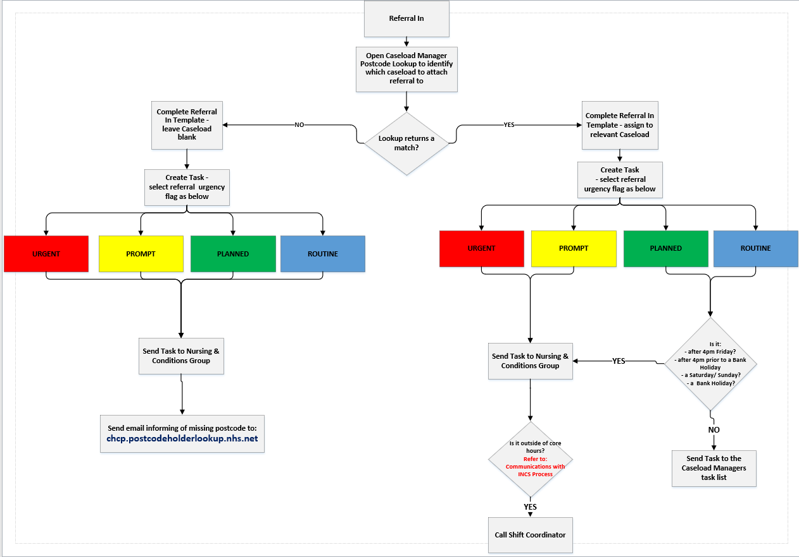
Note:
It is essential that CCH staff do not provide any patient / referrer with an indication of the service referral and response times. Patients and referrers should be informed that the referral / response will be triaged within the timeframes set below and a visit or appointment will be decided upon once the clinician has all the information to hand to be able to make an informed decision regarding the urgency of care required.
However, it should also be noted that referral requests for PROMPT care received after 12 noon will not take place the same day and patients / referrers should be informed of this at the time the referral is processed.

Referral Urgency and Response Times

 | Referral urgency for  NEW PATIENTS | Response times for  EXISITNG PATIENTS
URGENT  Flag: RED  Triage and response  within 2 hours if clinically required | Palliative Care:  Deteriorating palliative care patient including administration of medications for symptom management  Other:  Poor transfer of care / discharge from hospital  Prevent Admission – including Unscheduled Care Coordination (UCC) | Catheter Care:  Blocked - female / male / suprapubic catheter  Expelled - suprapubic catheter  - including home visits by CN team for patients with a Treatment Room referral)  Palliative Care:  Administration of ‘Just in Case’ medications  Syringe driver - management of problems  Verification of Expected Death - contact with family to discuss
PROMPT  Flag: YELLOW  Triage and response within  2 - 24 hours if clinically required | For same day care the referral must be received by 12 noon at the latest and the patient must be available to receive the care at the discharge address before 16:00hrs to allow for allocation of the visit the same day:  Medication Administration:  Insulin and low molecular weight heparin - self-care will be promoted  Palliative Care:  Administration of subcutaneous fluids  Venepuncture:  See specific advice in section 4.3  Wound Care: skin tears in Care Homes where assessment is requested following 7 days of first aid and management by Care Home staff, or where concerns are raised within the 7 days | Catheter Care:  Female / male / suprapubic catheter – problems including by-passing  Female / male catheter – expelled  includes home visits by CN team for patients with a Treatment Room referral  Palliative Care:  Verification of Expected Death completed - to be undertaken within 2 to 4 hours or as agreed with family  Wound Care:  Requests will be triaged and allocated according to clinical presentation, this may not be a same day response - with the exception of Negative Pressure (VAC) machine / dressing (PICO) failure.
PLANNED  Flag: GREEN  Triage and response within  24 - 72 hours if clinically required | Bowel Care:  Administration of enema  Administration of Suppositories  Symptomatic Bowel Cancer Two Week Wait pathway:  See specific advice in section 4.4  Pressure area care:  Assessment / care and management of vulnerable pressure areas with a pressure related skin injury evident  Assessment / dressing of pressure ulcerations  Wound Care:  Assessment of wounds requiring dressing including:  Wounds below the knee - follow Lower Limb Pathway guidance  Skin Tears – see above for Skin Tears in Care Home advice  Care / removal of post-operative drains  Central Lines:  Flush  Blood taking pre- treatment from CVAD  Chemotherapy pump disconnect | Wound Care:  Dressing removal by patients who lack engagement with their treatment plan
ROUTINE  Flag: BLUE  Triage and response after  72 hours | Bowel Care:  Routine bowel care / management - accepted for ongoing care only in exceptional circumstances and following clinical triage  Catheter Care:  Female catheter  Male catheter  Suprapubic catheter  Diabetic Annual Health Check:  Patients registered with a Hull GP only  Medications:  Subcutaneous and intramuscular injections / infusions  Enteral feeding:  Balloon gastrostomy (RIG) tube care  Percutaneous Endoscopic Gastrostomy (peg) care  Balloon gastrostomy (RIG) tube changes – Hull only  Mickey Button replacement – Hull only  Palliative Care:  Palliative care needs and support with some elements via telephone when appropriate  Observations:  Blood glucose recording – only in exceptional circumstances following clinical triage  Blood pressure recordings - see specific advice in 4.3  Specimen Collection:  Lower vaginal swabs – Residential Homes only  Venepuncture:  See specific advice in 4.3  Wound Care:  Follow up of wound already seen by HCP  Post Operative wound care i.e. removal of Clips / Sutures (date to be provided by referrer)  Wounds below the knee - follow Lower Limb Pathway guidance | Observations:  Blood glucose recording  - only in exceptional circumstances  Blood Pressure readings – will take place at next planned visit

4.3 Referral Criteria and Response Times for Phlebotomy and Blood Pressure Recording Requests for all Housebound Patients
This guidance is taken from the Memorandum of Understanding between CHCP and East Riding GP’s and the Hull service specification - hence some minor differences.

East Riding: accept and undertake all phlebotomy and blood pressure recording requests

Hull: - accept and undertake all phlebotomy and blood pressure recording requests. However, DO NOT accept Annual / QOF requests for patients not registered with the service.

For both areas: the following points must be observed prior to any referral been made:
- The patient must be made aware of the referral request by the referrer
- The referrer must have established that the patient is housebound and clearly document on the referral form
- If the patient is not available at the time the nurse visits the referrer will be informed and the patient will be discharged from the Nursing and Conditions caseload
- Requests should not be made more than 4 weeks prior to the required due date
- Patients requiring ongoing monitoring for medications purposes e.g. INR’s , lithium levels will remain on the Community Nurse caseload and will be actively managed by the Caseload Holder – NB: the frequency of monitoring required must be stipulated by the referrer and must be at intervals of less than 12 weeks apart. In addition, a clear clinical rationale and any management plan from referrer included at time of referral

RESPONSE TIMES - Do Not accept referrals for ‘ASAP’
- PROMPT:
- visits will be completed within 2 to 24 hours of the referral being accepted (Monday to Friday only - excluding Bank Holidays )
- the patient must have been seen by GP / HCP within 24 hours of the referral request / or referral received from Pathology
- there must be a clinical rationale provided for the request and details of who will, and when the results will be reviewed – this may include the ‘Symptomatic Bowel Cancer Two Week Wait pathway’
- the request must be received by 12.00hrs for a visit the same day, otherwise the visit will be completed the next day (Monday to Friday only - excluding Bank Holidays )

- ROUTINE:
- visits will be completed from 72 hours to 4 weeks of the referral being accepted
- all requests other than those deemed PROMPT will be treated as ROUTINE and will be prioritised according to the referral information within the above time frame.

- ANNUAL QOF PHLEBOTOMY / BLOOD PRESSURE REQUESTS:
- for patients known to the Integrated Nursing and Conditions service all phlebotomy and blood pressure recordings will be completed at the next planned visit to the patient, or sooner in exceptional circumstances when clinically indicated and there are infrequent visits planned e.g. catheter care patients
- for patients not known to the Integrated Nursing and Conditions service all phlebotomy and blood pressure recordings will be completed within 8 weeks of the referral being accepted.

4.4 Symptomatic Bowel Cancer Two Week Wait Pathway
CHCP Nursing and Conditions service have agreed to support GPs with patients who require further tests and investigations of their symptoms that could possibly be bowel cancer related.
The Symptomatic Bowel Cancer Two Week Wait Pathway support offered by CHCP will include the taking of a venous blood sample and the provision of a Faecal Immunochemical Test (FIT) kit, which the patient will then need to undertake and return to their GP when they have obtained a sample for the test.
CHCP working with GPs in this way will improve the fast-track pathway for symptomatic housebound patients by ensuring that the patient receives timely interventions and potential for further delay to investigations and treatment is reduced. Provision of these tests will also reduce the need for invasive hospital procedures such as colonoscopy for those who can be ruled out by simply having venous blood and FIT tests undertaken.
To ensure that all parties involved in the pathway understand each other’s role the following responsibilities have been agreed:
GP Responsibility:
- Identifies patient with relevant symptoms and confirms that the patient is housebound and no alternative other than a Community Nurse home visit is feasible
- Makes a planned referral to CHCP Care Coordination Hub on 01482 247111 i.e. intervention will be undertaken within 24 – 72 hours of referral being made
- Cleary states at time of referral that ‘Symptomatic Bowel Cancer Two Week Wait pathway’ is required
- Provides specific details of the venous blood samples required
- Explains to the patient what will happen and that the patient will be given the FIT test from Community nursing and the patient will need to perform the test and ensure that this is returned to the surgery
- Follow up results of both venous blood and FIT tests
- Liaises with the patient if no FIT is returned and reported upon
- Ensures that the patient can make alternative arrangements if the patient themselves is unable to complete FIT test or return sample to practice once sample taken

CHCP Community Nursing Services:

- Order FIT kit stock from Path Lab
- Ensures a small supply to be held in each base and readily available for supply to the patient when a test is required
- Applies the ‘Venepuncture / Bowel Screening (FIT test delivery) care plan to the patient record at the point of Triage
- Allocates the visit to a suitably trained and competent member of staff
- Undertakes the home visit and obtains venous blood sample as per request
- Leaves the FIT kit with the patient
- Advises the patient to liaise / contact their GP should they raise any concerns

Patient:
- Obtains the sample following the instructions provided in the FIT kit, with family / carer support as necessary
- Returns the FIT Kit to GP practice when sample obtained
- Seeks family / carer to support with above if needed
- Contacts GP for support with any concerns
CHCP – Symptomatic Bowel Cancer Pre - Screening flow chart

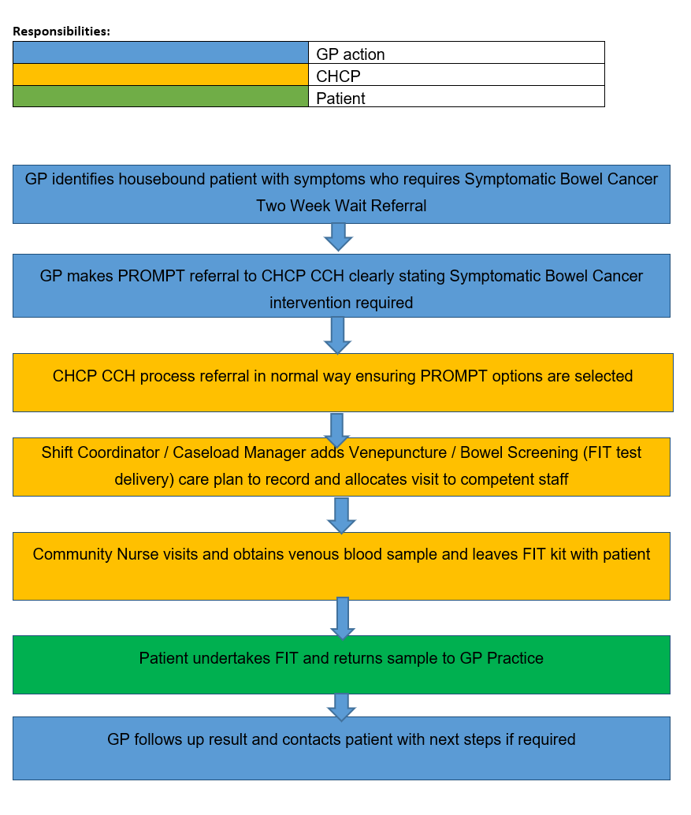

DISSEMINATION, IMPLEMENTATION AND ACCESS
This document will be available for staff to access as below:
- CCH – U: Folders
- INCS – MyCompliance: Ref 1246 Referral and Call Management for INCS Process Guidance - Related item Ref 5

APPROVAL
This process has been reviewed and approved by representatives of both the Care Coordination Hub and Integrated Nursing and Conditions Service.

MONITORING AND COMPLIANCE
This process will be continually monitored and assessed for its correctness and accuracy. A review will be conducted on a 3 yearly basis.

