**SPEECH AND LANGUAGE THERAPY REFERRAL GUIDANCE**

**CHILDREN’S SERVICE**

**General Information**  For referrals to be accepted by the speech and language therapy service you need to complete a referral form. If appropriate, this can be accompanied by a letter.

**Children with speech sound difficulties**  Current evidence indicates that direct therapy is often not appropriate to children under 4 ½ years for the following reasons:

* Children may improve naturally with maturity
* Young children often have difficulty following adult directed tasks
* Many therapy activities aim to develop speech sound awareness skills which typically don’t develop until a child is 4 ½ years or older

There may be exceptions if the child’s sound system is severely restricted.

Children may not produce all the sounds and sound combinations in words correctly until over the age of 7. Referrals are not accepted for the following difficulties unless the **child** is significantly concerned:

* a ‘lisp’ (‘s’ is said as ‘th’ eg ‘sock’ becomes ‘thock’)
* ‘r’, ‘l’, ‘ch’ – children may not acquire these sounds until 7 years

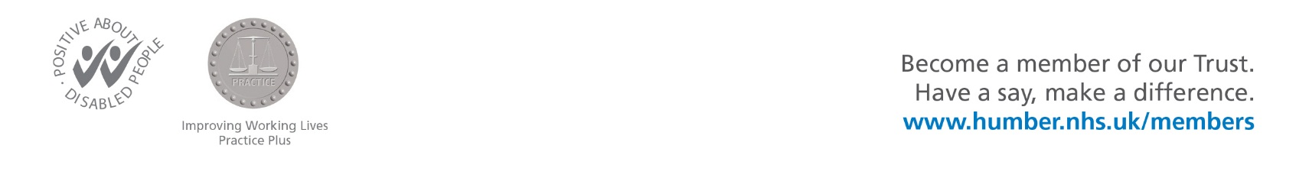

**Children with difficulties in understanding language and using sentences** The speech and language therapy service accepts referrals for children who have a *specific* speech, language and communication need.

Parents are often very concerned about their child’s speech and language development. If the child is below school age, it may be useful for the Health Visitor to go through the SLT pre-school referral checklist with the family to reassure/seek further information. However, if there is clear reason for concern, there is some information you can give parents that may help their child.

* Signpost the parents to the speech and language therapy website - <http://www.humber.nhs.uk/services/paediatric-slt.htm> . On this site there are some links with information for parents on how to promote their child’s speech and language development
* Signpost to local Children’s Centre groups (if available) which specifically target language development eg Talk time
* Discuss attendance at pre school/nursery if appropriate

For those children whose language skills are ‘on par’ with other areas of learning we offer a range of training courses for practitioners working in nurseries and schools. These courses will provide them with a toolkit of strategies and activities in order that children’s speech and language can continue to develop alongside other areas of learning.

**Children with eating and drinking difficulties** Children with eating and drinking difficulties where there are concerns about safety of swallow require a referral form or letter outlining the difficulty. It is important that any relevant medical information is included with the referral.

Babies and children who are struggling with weaning to lumpy food or are fussy eaters can generally be signposted to the Health Visiting team.

**Children who stammer**  Stammering can develop in children from an early age. Please refer any child who is repeating words/sounds (*b-b-baby*), prolonging words (*looook*) and/or getting stuck often at the beginning of words. We would also encourage referral of children who are showing signs of tension when talking or seeming reluctant to talk in front of other people.

**Children with voice difficulties**

Children who regularly have a hoarse voice, lose their voice or experience tightness when speaking require a referral to Ear, Nose and Throat (ENT) department. The ENT consultant will then make an onward referral to speech and language therapy if appropriate. This is to ensure that any medical reason for the voice difficulty has been investigated first.

**Children with social communication difficulties**

Children, who have difficulties initiating or responding to social communication, using communication for social purposes, developing social relationships, making their needs known, sharing information and participating in a two–way conversation may need further assessment.

Social communication difficulties may suggest an Autism Spectrum Condition. If the child has already been referred to an autism assessment and diagnosis service, the speech and language therapists who carry out assessments for the diagnostic teams may assess the child as part of that process. In this instance referrals to the speech and language therapy service need not be made unless there are additional unmet social communication needs.

**Loss of speech or language skills**

Sometimes children seem to be acquiring speech and language skills, but then regress and stop using these words, and fail to acquire new words. Please refer any child who is showing this pattern.

**Children whose first language is not English**

Children who have recently started to learn English are expected to have smaller vocabulary, use less grammatically correct sentences, and have difficulty understanding complex instructions. They may be fluent in their home language. They will not require referral to Speech and Language Therapy.

Children who are having difficulty in acquiring home language, or having difficulty in both languages should be referred.