Transcribing within Integrated Nursing and Conditions Service Standard Operating Procedure

Reference No: | 933
Version: | 4.1
Author: | Emma Baggaley – Assistant Director of Medicines Management  Tracy Turner – Professional Lead
Second Author
First Issued On: | 01st August 2019
Latest Issue Date: | February 2026
Review Date: | November 2026
Referenced Documents: | See reference section
Ratified By: | Therapeutics and Pathway Group
Distribution: | MyCompliance, Community Nursing Teams, GP Practice Staff, Local Medical Committee, The Local Pharmaceutical Committee

Document Revisions
Date | Author | Nature of Change | Reference
August 2024 | Emma Baggaley | Remove S1 label as service now paper light  Expand number of medications that can be transcribed | V3.1
December 2024 | Tracy Turner | Full Review  Addition of Palliative Care Medication | V4
February 2026 | Tracy Turner | Addition of details relating to transcribing drugs prescribed by brand | V4.1

This document can be found on CHCPs Document Management System (My Compliance)
Please make sure you use the most current version.

CONTENTS
Section | Title | Page
1. INTRODUCTION 3
2. PURPOSE 3
3. SCOPE 3
4. FAIRNESS, RESPECT, EQUALITY, DIVERSITY, INCLUSION & ENGAGEMENT 3
5. ABBREVIATIONS & DEFINITIONS 4
6. PROCESS 5
7. APPROVAL 23
8. MONITORING & COMPLIANCE 24
9. REVIEW 24
10. REFERENCES & ASSOCIATED DOCUMENTATION 24
11. APPENDIX 1 – Viewing EMIS Shared Care Record through SystmOne 25

INTRODUCTION
Transcribing can be defined as the act of making an exact copy, usually in writing. In the context of this Standard Operating Procedure (SOP), transcribing is the copying of previously prescribed medicines details to enable their administration in line with legislation (i.e., in accordance with the instructions of a prescriber) (RCN 2019).
This SOP must be read in conjunction with CHCP Ref 672 Guide to Safe and Secure Handling of Medicines.

PURPOSE
The purpose of this document is to describe the standard operating procedures for Transcribing within Integrated Nursing and Conditions Services (Adults). This SOP also describes the process for transcribing of palliative care medication, for the purposes of recording administration, by community nurses and the palliative care team. This process will be piloted with GP surgeries and then further rolled out across Hull and East Riding.

SCOPE
To provide an agreed framework, with specified parameters, which allows the process of transcribing to take place within a safe and supported environment. This SOP will be used to allow transcribing all injectable medication by community nurses and palliative care teams across Hull and East Riding for the purposes of recording administration of the medication

FAIRNESS, RESPECT, EQUALITY, DIVERSITY, INCLUSION & ENGAGEMENT
CHCP promotes the principles of FREDIE (Fairness, Respect, Equality, Diversity, Inclusion and Engagement) throughout the organisation and beyond. Whilst supporting and sustaining an inclusive and diverse workforce that is representative of the community it serves, equally we are committed to the provision of services that not only respect our increasingly diverse population but also which promotes equity of access and care.

ABBREVIATIONS & DEFINITIONS
Abbreviations:
JIC Just in Case
SOP Standard Operating Procedure
RCN Royal College of Nursing
FREDIE Fairness, Respect, Equality, Diversity, Inclusion & Engagement
EIA Equality Impact Assessment
CHCP City Health Care Partnership
SCR Summary Care Record
MAR Medication Administration Record
NHS National Health Service
g Grams
mg Milligram
ml Millilitres
IV Intravenous
INH By Inhalation
IM Intramuscular
SC Subcutaneous
PR Per Rectum
PV Per Vagina
PO By Mouth
NEB By Nebuliser
Oral By Mouth
Gastro/PEG By Gastrostomy
Top Topical
T Transcribing
CN Community Nursing
DSN Diabetic Specialist Nurse
GP General Practitioner
Rx Prescription
PRN As needed (pro re nata)

Definitions:
SystmOne Electronic Patient Record System
EMIS Electronic Management Information System

PROCESS
Staff members who transcribe are accountable for their actions and omissions. To be considered for the transcribing role a nurse must:

- be in a Band 5 position or above, assessed and recorded as competent in the administration of medicines

- undertake training in transcribing and be assessed as competent to transcribe by their line manager. Assessment of competency will be reviewed annually.

- have completed their initial probation period.

Transcribing cannot be undertaken within the electronic system. Transcribing can only be undertaken by hand onto the CHCP medication chart for the purposes of recording administration of a medicine.

Transcribing the information is copying from the sources below without any alterations or additions. Changes may not be made based on information provided by the patient, family member or carer. If information is provided by the patient regarding any changes to their medication, then the nurse must liaise with the prescriber for clarification.

In most instances the community/hospital pharmacy label is the primary source used to transcribe, however, to ensure safety and reduce risk, the details on the label must be checked against a second source from the following list:

- List of medication obtained from the patient’s electronic medical record (SystmOne or EMIS). For guidance on how to view the EMIS record, see Appendix 1.

- List of medication obtained from the patients Summary Care Record (SCR) following patient consent

- Discharge prescription/immediate discharge summary written in the hospital where the service user has been

The second source used must be documented in the patient’s electronic S1 record.

Only use recently dispensed medicines with a pharmacy label as evidence of current drug treatment (e.g., dispensed within the last month unless a patient was given more than one month’s supply at time of dispensing or if a patient has been prescribed JIC palliative care medication in advance). The dose on the pharmacy label (i.e. prescribed dose) must match the dose that is transcribed on the medication chart.

Nurses MUST not amend or write on the pharmacy label to update a dose. It is permissible to cross through the pharmacy label for JIC medications when the prescriber has provided written evidence of a dose change, see section 6.8.

All patients referred into community nursing teams must give consent to their medical records sharing, those deemed not to have the mental capacity to consent must have the appropriate authorisation for sharing through Lasting Power of Attorney (Health and Wellbeing), Best Interest Assessment or Court Order.

6.1 Transcribing Process
- Fill in all required fields on the CHCP Medication Administration Record (MAR) relating to medicines and patient details. Partial completion can lead to delays and errors.
- Write legibly (in capitals) using a ballpoint pen, in black ink

- It is the transcriber’s responsibility to enter the following in block capitals

- Patient’s full name & address
- NHS number
- Date of birth
- Recent weight (and date recorded)

- Enter details of drug and other allergies in the appropriate section when initially completing the MAR. If none are known, then this must also be indicated. Information added on allergy status must be signed and dated at the time of entry or amendment

- All medication details should be clearly legible to include:

- Medication name
- Form of medication e.g., tablet, capsule, powder for injectable, solution
- Strength e.g., 10mg. The following units may be used for expressing strength or dosage:

- g = grams
- mg = milligram
- ml = millilitres
- micrograms - must be written in full
- nanograms - must be written in full
- ‘units’ - must be written in full

- Dose and frequency e.g., 10mg TWICE A DAY.
- Write out the frequency in words and not figures e.g., THREE TIMES A DAY or THREE x DAILY, not 3 times a day or 3 x daily
- Indicate the route of administration clearly, accepted abbreviations are:

- IV = Intravenous
- SC = Subcutaneous
- PR = Per Rectum
- PV = Per Vagina
- INH = By Inhalation
- PO = By Mouth
- IM = Intramuscular
- NEB = By Nebuliser
- Oral = By Mouth
- Gastro/PEG = By Gastrostomy
- Top = Topical

All other routes should be written out in full e.g., Sublingual Buccal.
Only one route should be indicated for a given administration time.

- The date of the transcribing. The transcribing nurse must print their name, sign and date the MAR and annotate that they have transcribed the medication using a capital T circled

- Any additional directions or information in the special instructions box e.g. with food

- The use of decimal points should be avoided where possible e.g. transcribe as 200 micrograms and not 0.2mg, or transcribe as 2mg and not 2.0mg
- If small volumes are prescribed (less than 1ml) write as 0.5ml and not .5ml

- Medication labelled as “as directed” must not be transcribed onto the CHCP MAR chart. Contact the independent prescriber who will need to produce another FP10 with clear dosage instructions on or complete a CHCP MAR chart with clear prescribed instructions to allow a nurse to administer the medication

- Ensure any indications for `as required drugs` are copied. The dose interval should be specified (e.g. every 4 hours) as well as the maximum quantity that could be administered (e.g. max 30mg in 24 hours)

- Multiple CHCP MAR charts must be condensed onto one chart whenever it is possible. If the patient requires more than one CHCP MAR chart, mark clearly on the front of the card `1 of 2’, or `2 of 2’ etc

- For drugs that have been prescribed by brand, the brand name should be transcribed exactly as prescribed and as it appears on the dispensing label, with the strength and formulation documented. The drug name can be added in brackets as this should help avoid duplication should the same drug be prescribed as an alternative brand as in the example below:
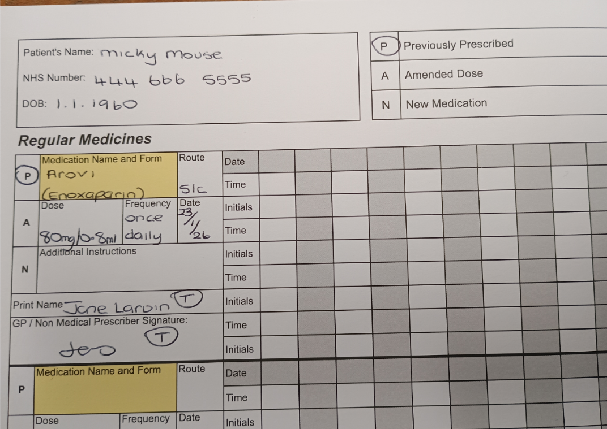

- The whole CHCP MAR chart must be re-written when it becomes messy or illegible, especially after several medications have been stopped or changed or when the CHCP MAR chart is full. If the CHCP MAR is full and the current medication the patient is administered is still in use, then the prescribed dosage instructions can be transcribed on to a new CHCP MAR. When a new CHCP MAR sheet is written the old one should be cancelled by drawing a diagonal line across it and writing ‘re-written’. The nurse must then print their name, sign and date the sheet

- When a new item is prescribed midway through a CHCP MAR then the signature and time administered cells should be scored through for the dates prior to the additional item being added

- At the present time, we will continue to use the CHCP Medication Authorisation and Administration Record Charts. When transcribing, the nurse must print their name, sign the chart, and annotate the transcription with a T

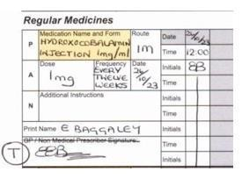

6.2 Cancellation of Treatment
- Do not discontinue any prescribed treatment unless documented evidence from the independent prescriber is available. The source of the evidence must be documented in the patient’s record

- If the medication is discontinued, the CHCP MAR chart should be annotated with the reason for the discontinuation, name of nurse annotating the CHCP MAR and the date. A single bold line must be drawn diagonally across the details of the medication on the CHCP MAR chart and any remaining unused administration record on it

6.3 Change to Treatment Dose
- If the change in dose is to be transcribed then the prescriber will need to produce a new FP10, with clear dosage instructions, which will be dispensed by a pharmacy who can then add the prescribers instructions on the pharmacy label. These changes need to be in place to allow transcription of the new dose onto the MAR before changes are made to administration. Amended doses should be cancelled as above and then re-written. Any boxes which contain a pharmacy label with the “old” dose must be discarded, medication that is still in date can continue to be used to administer the updated dose to the patient (for diabetic medication see administering medication section, diabetic medication (injectable)).

Immediate and necessary change to a treatment dose
- In exceptional circumstances, where medication has been previously prescribed and the prescriber is unable to issue a new prescription, but where changes to the dose are considered immediate and necessary, the use of information technology may be used but must confirm any change to the original prescription. A verbal order on its own is NOT acceptable. A new prescription should be generated and signed by the prescriber who confirmed the changes within normally a maximum of 24 hours (72 hours maximum – bank holidays and weekends). When written confirmation to the dose change is received, the new dose can be transcribed onto the CHCP MAR chart. Acceptable written confirmation which can be viewed and acted upon by the transcribing nurse is as below:-

- For GP’s using SystmOne and the GP Out of Hours Service, the prescriber should add an entry into the SystmOne patient record detailing the dose change

- For GP’s using EMIS, the prescriber should issue an FP10 via electronic prescribing which can be viewed by the transcribing nursing using third party record (see Appendix 1)

- The transcriber must document within S1 that they have amended the dose based on written authorisation and a new prescription has been requested. There will be a difference between the MAR Chart and pharmacy label for a short period of time until the new prescription (with the updated dose) is received. This information should be added to the visit list within S1 to inform the next visiting nurse

Controlled Drugs
Any change in dose to a prescribed controlled drug needs to be covered by a new direction to administer that needs to be in writing. If the GP/prescriber record can be accessed and a new prescription can be seen to have been issued with an increased dose, then this is sufficient written evidence that there is a new direction to administer.

Acceptable written confirmation which can be viewed and acted upon by the transcribing nurse is as below:-
- For GP’s using SystmOne and the GP Out of Hours Service, the prescriber should add an entry into the SystmOne patient record detailing the dose change

- For GP’s using EMIS, the prescriber should issue an FP10 via electronic prescribing which can be viewed by the transcribing nursing using third party record (see Appendix 1)

The transcriber must document within S1 that they have amended the dose based on written authorisation and a new prescription has been requested. There will be a difference between the MAR Chart and pharmacy label for a short period of time until the new prescription (with the updated dose) is received. This information should be added to the visit list within S1 to inform the next visiting nurse

6.4 Medicines which can be Transcribed
The table below lists the most common medications which community nursing teams will transcribe. If a prescriber is unable to provide a CHCP MAR chart and they have issued a prescription with clear specific instructions on how to administer a medication and a second source can be checked, then these medicines can be transcribed onto a CHCP MAR chart for the purposes of recording administration.

Medicine | GP/Prescriber responsibility | Nurse responsibility
Hydroxocobalam in  (Vitamin B12)  To be administered intramuscularly | GP to issue prescription for  hydroxocobalam  in injection with clear dose instructions e.g.  Loading dose – X doses to be given over  TWO weeks  Or  Maintenance dose  1 mg to be  administered once every 12  weeks | Nurse to use pharmacy label as primary source from which to transcribe.  Second check the dose against the  patient’s  electronic medical record or patient’s SCR.  Administer the medication in accordance with the prescriber’s  instructions | If the prescription is issued with “as directed”, this cannot be transcribed on the CHCP MAR.  Nurse will need to request a new  prescription from the GP with clear dosage  instructions or GP will need to complete Medicines Administration and Record Chart to authorise administration.

Dalteparin  To be administered by Subcutaneous  injection | GP to issue prescription for Dalteparin with clear dose instructions e.g.  5000 units to be administered  DAILY  GP to specify the duration of treatment. | Nurse to use  pharmacy label as primary source from which to transcribe. Second check the dose against the  patient’s  electronic medical record or patient’s SCR. Administer the medication in  in accordance with the prescribers instructions | If the prescription is issued with “as directed”, this cannot be transcribed on the CHCP MAR.  Nurse will need to request a new  prescription from the GP with clear dosage  instructions or GP will need to complete Medicines Administration and Record Chart to authorise administration

Enoxaparin  To be administered by  Subcutaneous injection | GP to issue prescription for Enoxaparin with clear dose instructions e.g.  2000 units to be administered  DAILY  GP to specify the duration of treatment. | Nurse to use pharmacy label as primary source from which to transcribe.  Second check the dose against the  patient’s electronic medical record or patient’s SCR.  Administer the medication in accordance with the prescribers instructions | If the prescription is issued with “as directed”, this cannot be transcribed on the CHCP MAR.  Nurse will need to request a new prescription from the GP with clear dosage  instructions or GP will need to complete  Medicines  Administration and Record Chart to authorise administration.

Diabetic  Medication (injectable)  e.g. Insulin and GLP – 1RA (i.e. liraglutide, semaglutide, dulaglutide, lixisenatide and exenatide)  To be administered by  Subcutaneous  injection | GP to issue prescription for diabetic injectable medication with clear dose instructions  e.g. 6 units in a morning and 10 units at teatime.  Change of  dose. If the prescribed dose of diabetic medication is changed, then a new prescription is required to be generated by the GP with clear dose and instructions and inform  Community  Nursing via  247111 of a change of dose.  To reduce the amount of waste medication, nurses will request the | Nurse to use pharmacy label as primary source from which to transcribe.  Second check the dose against the patient’s electronic medical record or patient’s  SCR.  Administer the medication in accordance with the prescriber’s instructions.  Upon receipt of diabetic medication with  pharmacy  label with the amended dose, the nurse will cancel the old dose from the CHCP MAR.  The new diabetic medication dose | If prescribed as ‘as directed’ the nurse is unable to transcribe the dose and will require another prescription with clear dosage instructions or GP will need to complete  Medicines  Administration Record Chart to authorise administration.
 | smallest number of diabetic pen devices e.g. 2 pens rather than a box of  5 pens | will be transcribed onto the  CHCP MAR  Nurse to amend the  title of the diabetic care plan within S1 as  ‘Transcribed’  See also flow chart ‘Diabetic  Injectable Medication change of dose’

For injectable palliative care medication, see palliative care section

6.5 Administering Medication
When a member of staff is administering medication from a CHCP MAR chart which a nurse has transcribed, before administering the medication they must ensure that the directions on the pharmacy label of each medication matches the transcription.
If there are any discrepancies, investigation into the reasons for this must be undertaken before administration takes place.

6.6 Diabetic Medication (Injectable)
The current diabetic medication pen device that is in use by the nursing team (and kept out of the fridge) will be stored with the CHCP MAR chart and the medication box with the pharmacy label that states the current dose of medication. This pharmacy label can then be checked against the CHCP MAR chart prior to administration of diabetic medication. A photograph of the current pharmacy label will also be uploaded on S1 (see flow chart below).

The remaining diabetic medication will be stored in the fridge in a sealable container e.g. plastic Tupperware container.
If a patient has more than one type of diabetic medication device, a separate box will be needed for each device.

6.7 Diabetic Injectable Medication: Change of Dose (non-urgent change)

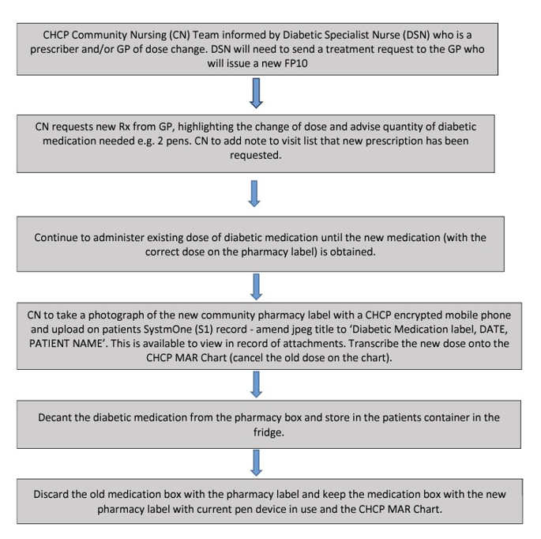

NB: If the pharmacy has dispensed and labelled each individual insulin pen device with dosage and frequency, then these pens will need to be discarded if there is a change in dose

6.8 Palliative Care Anticipatory Medications PRN injection
The example doses given below would be suitable for an opioid and benzodiazepine naive patient only and are taken from the area prescribing committee guidelines:
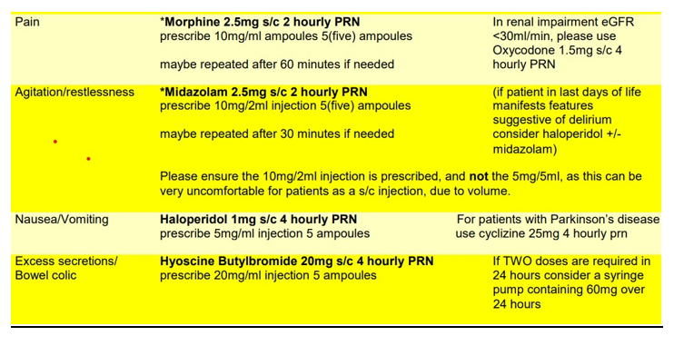
Initial prescriptions for PRN injections will be provided by the prescriber and may be transcribed onto the CHCP MAR chart. The prescription must specify clear dosage instructions including rationale e.g. pain/agitation.

NB: Prescriptions with a sliding scale dose cannot be transcribed.
If a sliding scale prescription is issued, the community nurse will contact the prescriber and request a specific dosage direction.

For a non-urgent change of a dose for PRN medication then the following process will be followed (see section 6.3 for the urgent change of dose process)

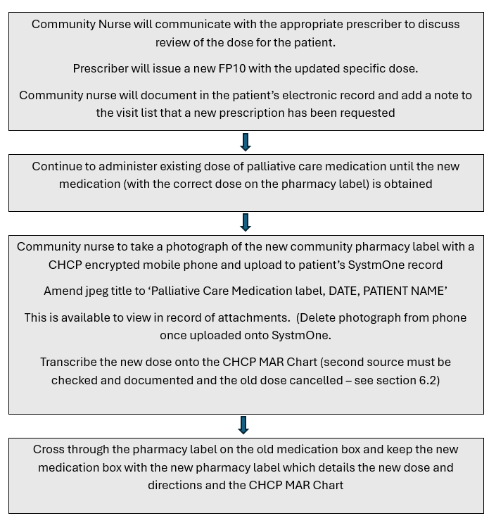

6.9 Palliative Care Medication via sub-cutaneous Continuous Infusion
When transcribing palliative care medications for administration via sub-cutaneous continuous infusion (syringe pump), the prescriber must issue an FP10 prescription for the drug(s) required according to the patients’ symptoms. The prescription must specify clear dosage instructions including rationale e.g. pain/agitation
NB: The prescriber will also need to issue a prescription for the appropriate diluent i.e. water for injection
If the above is in place, then the palliative care medications for sub-cutaneous continuous infusion can be transcribed on to the CHCP MAR chart by the community nurse as per the process above. When there is a change in dose for sub-cutaneous continuous infusion then the process below should be followed.
NB: Prescriptions with a sliding scale dose cannot be transcribed.
If a sliding scale prescription is issued, the community nurse will contact the prescriber and request a specific dosage direction.

6.10 Palliative Care Medication via sub-cutaneous Continuous Infusion: Change of Dose
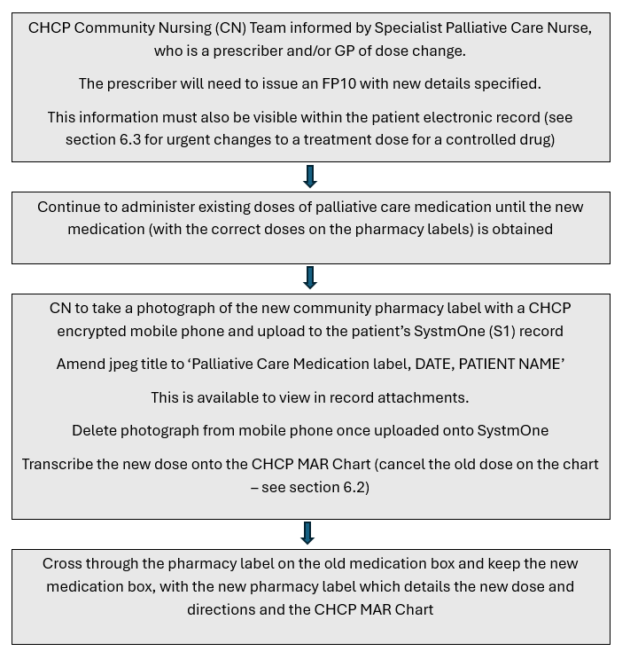

APPROVAL
This guidance has been reviewed and approved by the stakeholders identified on the document checklist submitted to the Therapeutics and Pathway Group which reviewed the checklist and ratified this document.

MONITORING & COMPLIANCE
Incidents relating to transcribing will be recording on CHCP incident reporting system and will be reviewed and reported to the Therapeutics and Pathway Group.

REVIEW
This guidance will be reviewed every 2 years or sooner as needed as the transcribing programme is rolled out across Hull and East Riding.

REFERENCES & ASSOCIATED DOCUMENTATION
References:
CHCP Ref 672 Guide to Safe and Secure Handling of Medicines

Associated Documents:
CHCP Ref 118 Medicines (including Controlled Drugs) Policy
CHCP Ref 480 Diabetic Medication Protocol
CHCP Ref 593 Referral and review requests for the Diabetes Specialist Nursing Teams
Microsoft Word – Herpc – April 2017

APPENDIX 1 – Viewing EMIS Shared Care Record through SystmOne

SystmOne and EMIS Integration – Introduction
Currently SystmOne has direct shares with other GP Practices that deliver care through SystmOne, allowing Clinicians to view a patient’s GP record, where relevant shares are in place. CHCP have recently joined a pilot that will also allow viewing into EMIS records, meaning we will also have visibility of those patients registered within EMIS Practices. As with SystmOne this will be dependent on the relevant shares being available.

This document will outline:
- Which records will be shared with EMIS
- How to view a patients EMIS record

Which records will be shared with EMIS?
The sharing consent for the patient at your organisation is highlighted in bold. To share data from SystmOne to an EMIS organisation, the patient must have consented to share out. This is indicated by a Yes or a Not asked – Record shared in the Consent column.
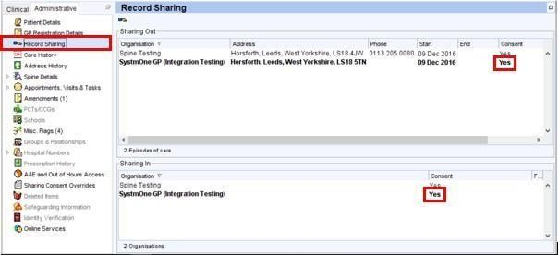

In order to view EMIS records in SystmOne, the patient must consent to sharing in at the SystmOne organisation.

Before the record is sent to EMIS, the EMIS user will also need to record consent from the patient to view the SystmOne patient record.

Viewing a Patient Record sent from EMIS
Log on with a smartcard so you get the latest details from PDS for the patient

Note: If you are not logged on with a smartcard, you will not be permitted to use the integration. If a patient is flagged as Spine Sensitive, then you will not be able to use the integration for this patient

- Select Third Party Patient Record

- Select Check for Records - this will send a message to participating EMIS organisations querying whether EMIS has the patient registered and if information for the patient is available to be shared. The name of the organisation will appear as a new sub-node within the clinical tree

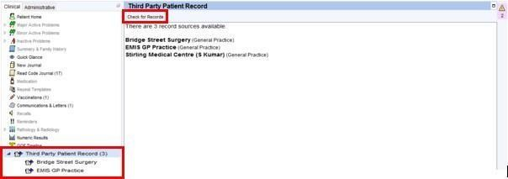
3.

Select the EMIS Practice from the list

Clicking on the name of the Practice from the Clinical Tree will retrieve the record from that organisation for the patient. The Summary view will be displayed by default.
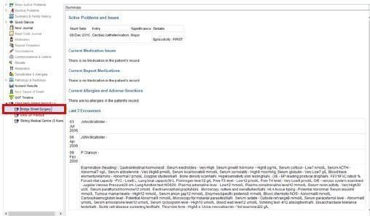

EMIS does not support the sending of data for three categories within the Summary.

This data may be present in the patient’s EMIS record. These categories are:

- Warnings
- Key Indicators
- Current Recalls
- Historical Allergies and Adverse Reactions
- Investigations
- Administrative Items

After retrieving the record, you can change the view using the drop-down menu

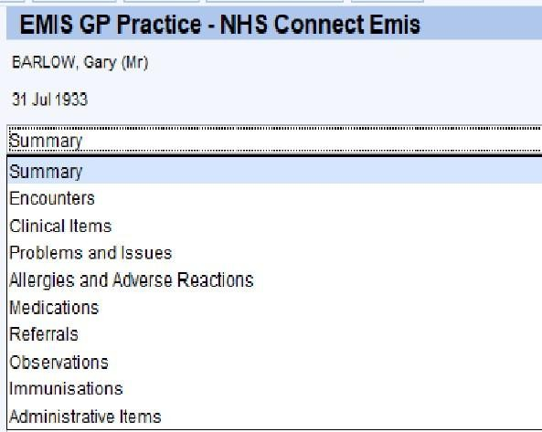

Some views have a date filter, which will default to show the last 6 months of information. Users can then change this date filter to request the information that they are interested in
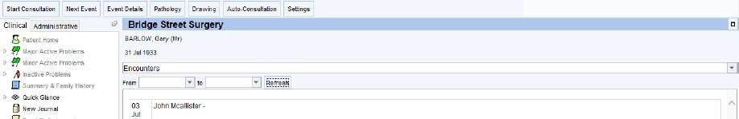

Pressing Ctrl+F on the keyboard will bring up a search dialog. This will make finding specific information in the record quicker and easier, particularly on screens that have a lot of information e.g. the Encounters view

