We are asked to see many babies who are not walking before 18 months. It is important to understand that babies walk at different rates. This can be for various reasons.

If your child is not yet walking it is important to consider the factors below:

I need opportunities and a safe space to move on the floor

Average age for achieving walking is between 8-18 months

I should not be compared to my siblings or family as we all develop at different stages


I may walk later than my friends if I commando crawl, bottom shuffle or have more flexible joints

I may walk later than my friends if I commando crawl, bottom shuffle or have more flexible joints.
The use of Baby walkers is not advised
I may walk later than my friends if I commando crawl, bottom shuffle or have more flexible joints.

Your child may have achieved some walking skills already. They may be crawling, pulling up to stand and cruising along the furniture. That’s fantastic and shows good progress. They might just need more time to practise before taking those first steps.

Here are some of our favourite activities to encourage your child to develop the skills needed for walking. Pick the activities that suit your child’s stage best. Remember to have fun…on your marks, get set….go!may walk later than my friends if I commando crawl, bottom shuffle or have more flexible joints.

walk later than my friends if I commando crawl, bottom shuffle or have more flexible joints.
I may walk later than my friends if I commando crawl, bottom shuffle or have more flexible joints.
On your marks…

Playing on the floor is important. It will help your child strengthen their muscles, learn about their body and explore their environment. Help your child to move in and out of the positions in these activities. Do them slowly to let your child do as much as possible.

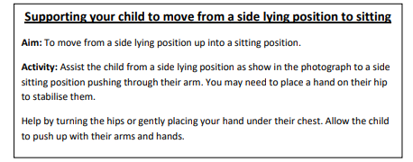
- Moving from lying to sitting

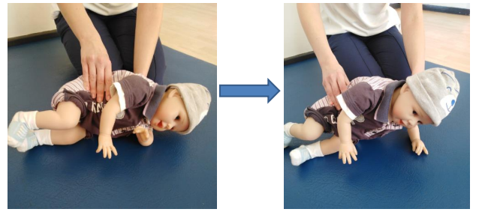

- Moving from sitting to lying
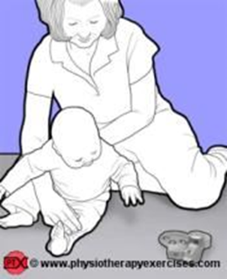 | Aim  To improve the ability to transfer sitting to lying.  Instructions  Position the child sitting on the floor. Place or hold objects just beyond of arm`s length. Encourage the child to reach for the objects and assist them to transfer into lying.

3. Playing in a crawling position

Your child might need some support under their tummy at first to help them stay in a crawling position. When they can do this themselves, encourage them to reach for a toy or roll a ball/ push a toy car.

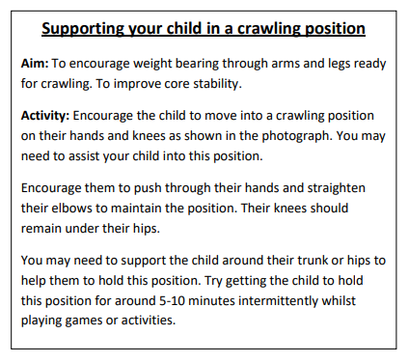

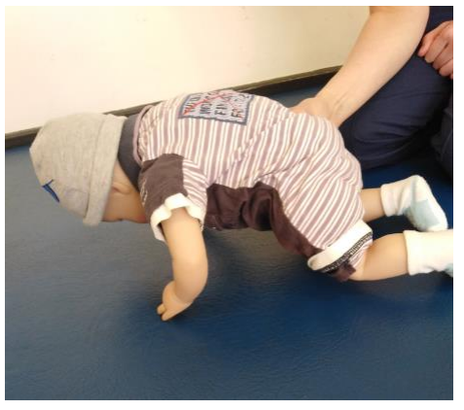

4. Weight bearing through feet:

Sit your child on your knee with their feet flat on the floor. Try not to let them lean back on you.

Encourage them to reach forward to the floor for toys. This begins to put weight through their feet to get ready for standing up. You can also put your hands on their knees to help gently put some weight though their feet.

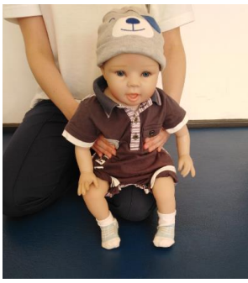

Get set…

Standing
The following activities are to help your child develop their standing.

1. From your knee or a small stool
Encourage them to stand up to see toys on a small table or sofa in front. Support their arms and encourage them to stand up as shown. Try not to pull them up.
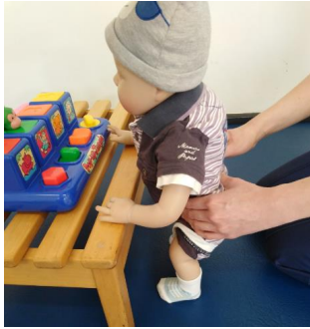

2. Play in kneeling

Encourage your child to kneel at a surface to play.
From this position you can then encourage your child to pull to stand. You might need to guide them up from their bottom or hips to begin with.

3. Standing at furniture

Encourage standing at furniture using both of their hands for support. Once they can do this, hold toys for them to reach up and to the side. This will help them to use their tummy and back muscles and develop their muscles for standing.

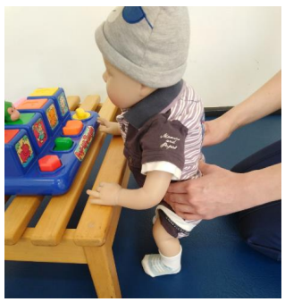

4. Cruising

Encourage your child to side step along a surface for toys or items that interest them. To begin with, you may have to guide them from their hips. Remember to practise moving to both sides.

5. Moving between surfaces

Once your child’s cruising has improved, encourage them to move between surfaces. Start with small gaps. This can be between two chairs or from a sofa to a small table. This will encourage them to step out to the side and start to challenge their standing balance.

6. Standing on their own

Practise standing. Support their hips or hold their arms from the front. As they become steadier, try holding them less firmly or try ‘letting go’ for a few seconds.

Scan these QR codes with your phone to open some videos which give examples of the above activities:

GO!

Your child will walk when they are ready. Here are a few things to try:
1. Use a push along toy
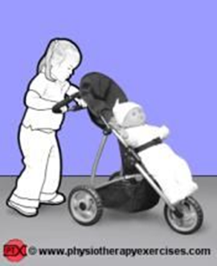
At first you may need to hold the toy steady so that it is not too far in front.

2. Hold your child’s hands from the front.

Guide them forwards to encourage stepping.

3. Stepping between surfaces
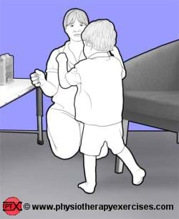
Make the gaps bigger between furniture and encourage your child to step between them. This could be from a sofa to a push along toy.

4. Try holding one hand instead of two.

Make sure that you are slightly in front of them to encourage them to step forwards. Don’t hold it too high.

Trips and Falls
Falling is part of normal development. Children will often fall up to 17 times an hour. Their balance and walking skills will improve with practise.
Encourage:
- short bursts of walking
- walking on different surfaces e.g. grass, stones, sand
- activities such as soft play, going to the park, swimming etc

Footwear

Young children who are not yet walking do not usually need shoes. Once your child is walking, you should make sure you buy the correct footwear for them.
Scan this QR code with your phone for more information on suitable footwear:

Baby Walkers
Physiotherapists and other Health Professionals do not recommend the use of baby walkers. There are two main reasons for this:

Safety – even under supervision there are high numbers of accidents reported every year including:
o falling down stairs
o head injuries
o burns, scalds
o trapped arms / legs

Delayed development – some studies have shown that baby walkers might actually delay standing and walking. Contrary to popular belief, they do not teach a child to walk. They can cause a child to walk on their toes which may continue when they walk independently.

If you are using a baby walker:

- Your child should have good head control and ideally be able to sit up by themselves
- Make sure both feet are flat on the floor, not on their toes
- Never leave your child unattended
- Never use near steps or open doors e.g., Patio windows
- Avoid use near open fires, cookers, radiators and trailing wires
- Check floor is free of objects that could cause tipping
- Your child can move at up to 7mph, faster than you can react
- Use for a maximum of 20 minutes at a time


Scan this QR code with your phone for more information on suitable baby walkers:

When to seek further advice from a health professional

Does your child have difficulty moving their arms or legs? Do they appear stiff or floppy?
Are they moving one side of their body more than other?
Are they unable to stand with both feet flat?
Are there significant concerns with delay in other areas of development? E.g. their play, language development, fine motor skills etc.

Please contact your Health Visitor or GP if you have any concerns.

We hope that you have found this booklet helpful. Please ensure that common sense prevails when following any of the activities we have suggested.
Do not hesitate to contact us if you have any questions about any of the information or activities or would like this booklet in a larger print.
**Please note Reference List available on request

We would like to thank NHS Lanarkshire for sharing their resources and good work with us to develop this document.

