Information to support decision making | Weblinks
Urgent Suspected Cancer (USC) is the new terminology for 2 week wait.  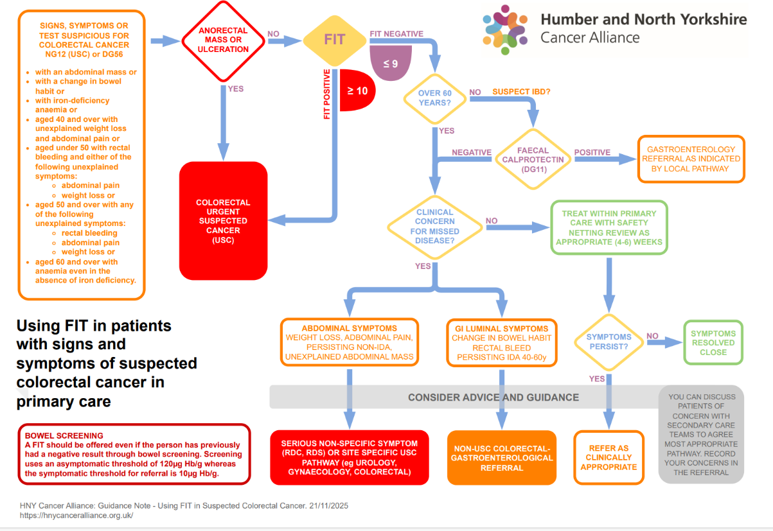 | NICE Suspected Colorectal Cancer referral guidelines NG12  British Society of Gastroenterology (BSG) and the Association of Coloproctology of Great Britain and Ireland (ACPGBI) on use of FIT in patients with signs or symptoms of suspected colorectal cancer.  NHSE letter on using FIT in the Lower GI pathway  NOTE: NICE published revised NG12 guidance in August 2023. For more details, ctrl click here
 | NOTEs:
Urgent Suspected Cancer (USC) is the new terminology for 2 week wait

FIT should be offered even if the person has previously had a negative FIT result through the NHS bowel cancer screening programme.

A FIT result enables patients to be prioritised to the correct service and enhances patient care to the right test at the right time. Please refer with a FIT result where possible.

If your patient is symptomatic (regardless of age) and FIT is below threshold (<10) then options to consider are:
- Consider referral on an urgent colorectal or other cancer pathways including Non-Specific Symptoms (NSS) where available
- Consider advice and guidance
Characteristic of bowel cancer – Red flags- To read the full paper, ctrl click here
- >50% of all patients with bowel cancer present with rectal bleeding in combination with a persistent and unremitting change in bowel habit to increased frequency of defaecation and looser stools (odds ratio 5.4*)
- >20% have a similar change in bowel habit without rectal bleeding (odds ratio 2.1-2.5*)
- >12% have persistent rectal bleeding without anal symptoms without a change in bowel habit (odds ratio 2.9*)
- <2% have abdominal pain (odds ratio 0.6†) as a single symptom, which is always provoked by eating, causing weight loss
- 25% have a rectal mass (odds ratio 31.5)
- 12% have an abdominal mass (odds ratio 1.8-8.5*)
- 8% have an iron deficiency anaemia with or without bowel symptoms (odds ratio 4.4-8.4*)
*Odds ratio on multivariate analysis. †Odds ratio of abdominal pain on univariate analysis without defining whether it is always associated with eating and weight loss

Specific recommendations
- A patient with rectal bleeding should have a FIT performed unless there is obvious anal mass or ulceration.
- A FIT threshold of fHb ≥10 µg Hb/g should be used in primary care to select patients with lower GI symptoms for an urgent referral pathway for colorectal cancer (CRC) investigation. However, patients should not be excluded from referral from primary care for symptoms on the basis of FIT testing alone
- Some patients with change in bowel habit symptoms could be managed in primary care if fHb <10 µg Hb/g, normal FBC and normal examination.
- Consider using faecal calprotectin as additional triage aid for bowel habit change in symptomatic patients where FIT is below threshold
- Faecal calprotectin pathway. For patients under 60yr old, Faecal calprotectin may be more appropriate for Change In Bowel Habit – if > 250 make an urgent pathway referral or use A+G, if the patient is fHb <10 µg Hb/g.
- Patients with an fHb <10 µg Hb/g but with persistent and unexplained symptoms for whom the GP has ongoing clinical concern should be referred to secondary care for evaluation;
  - where cancers other than colorectal are suspected please refer on appropriate suspected cancer referral form
    - consider possibility of upper GI cancers in patients with iron deficiency anaemia
    - consider pancreatic cancer in patients with weight loss and Change In Bowel Habit
    - consider possibility of an ovarian cancer in women over 50 where there is a change in bowel habit (perform vaginal exam, request CA125 and Trans Vaginal Ultrasound
  - if patient is presenting with vague symptoms not suggestive of a specific tumour site, please refer to a Non-Specific Symptoms (NSS) clinic where locally available
- Refer patients with persistent/recurrent anorectal bleeding for investigation on urgent or rectal bleeding pathway if fHb <10 µg Hb/g
Safety-netting options
- Repeat FIT at interval*, consider other causes bowel change, check faecal calprotectin
- Refer to Colorectal Suspected Cancer Service where patient has bowel specific symptoms
- Consider referral to NSS service where available and if the patient has no bowel specific symptoms
- Consider advice and guidance.
- Change In Bowel Habit >3 weeks. We should advise to consider stopping PPI/ Metformin SSRI before starting investigations

*Duplicate or repeat fit testing:
There is currently insufficient evidence to recommend use of repeat / secondary FIT to guide referrals in routine practice. NHS England have advised offering a second FIT test if ongoing clinical concerns remain. NICE review will take FIT study results before deciding whether or not to recommend repeat FIT.
Suspected Cancer Referral Guidance – What is contained in the referral document
Suspected Colorectal Cancer  ☐ Rectal mass  ☐ Unexplained anal mass  ☐ Unexplained anal ulceration  ☐ Patient unable to complete a FIT test due to physical/mental constraints but has colorectal symptoms  ☐ Suspected Colorectal Cancer - FIT above threshold (FIT ≥ 10)  Reason FIT was requested:  ☐ Abdominal mass  ☐ Change in bowel habit; or  ☐ Iron Deficiency Anaemia (IDA)  ☐ ≥ 40years with unexplained weight loss and abdominal pain  ☐< 50 years with rectal bleeding AND any one of the following  - Abdominal pain OR weight loss | ☐ ≥ 60 years with anaemia even in the absence of iron deficiency  ☐ Other clinical concern (please state) Click or tap here to enter text.  ☐ FIT is below threshold (FIT<10) but there is strong suspicion of colorectal cancer  (please state) Click or tap here to enter text.  Consider referring patient with unexplained persistent rectal bleeding and a FIT <10 via an urgent colorectal or rectal bleeding pathway where available
RESOURCES
- Suspected cancer: recognition and referral, NICE guidelines [NG12], 2015
- British Society of Gastroenterology (BSG) and the Association of Coloproctology of Great Britain and Ireland (ACPGBI) on use of FIT in patients with signs or symptoms of suspected colorectal cancer. 2022
- Have large increases in fast track referrals improved bowel cancer outcomes in UK? 2020, Thompson. M et al. BMJ2020;371:03273
- NHSE letter on using FIT in the Lower GI pathway 2022
- Nicholson, James, Paddon, Justice, Oke, East & Shine (2020)/ Laszlo, Seward, Aylin, Lake et al. (2020) /NHSE B2005
- Online Cancer Education for Primary Care staff – Gateway C FIT
- Online Cancer Education for Primary Care – Gateway C Early Detection of Colorectal Cancer

