


East Riding Community Hospital

Community Diagnostic Spoke

Spirometry and FeNO testing
In collaboration with Yorkshire Healthcare Partners
- Respiratory Specialist Medicine
- May 2025

Introduction

This leaflet has been produced to give you general information about your procedure. Most of your questions should be answered by this leaflet. It is not intended to replace the discussion between you and your clinician but may act as a starting point for discussion. If after reading it you have any concerns or require further explanation, please discuss this with a member of the healthcare team caring for you.

What is a spirometry and FeNO test?

You have probably been troubled by some symptoms. Following discussion with your doctor/nurse they have advised you to require a breathing test.
- Spirometry: Is a basic lung function test, involving blowing hard and fast into a mouthpiece until completely empty.
- Post Bronchodilator Response: After your breathing test we may give you some medication via a nebulizer followed or rest for 20 minutes before testing you again.
- Fractional Exhaled Nitric Oxide (FeNO): Is a basic breath test measuring airway inflammation.

Why do I need to do a breathing test?

You may have recently seen your GP/Healthcare professional and they would like to test your lung function. Spirometry and FeNO is a common test used to diagnose/rule out any airways disease.

Can there be any complications or risks?

The test may result is making you feel temporarily breathless and induce a cough. We will give you plenty of time to recover before repeating the test/sending you home.

How do I prepare for the tests?

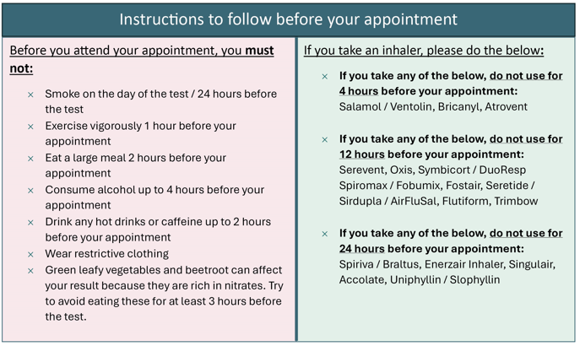

If any of the following applies, please cancel your appointment as we will be unable to perform any of the tests.
- You’ve had thoracic/abdominal surgery (< 6 weeks ago)
- You’ve had a heart attack/stroke (< 6 weeks ago)
- You’ve been coughing blood recently
- You’ve had a collapsed lung (< 6 weeks ago)
- You have a fractured rib (< 6 weeks ago)
- You’ve had eye surgery (< 6 weeks ago)
- You’re currently suffering with a blood clot on your lung
- If you currently have active TB
- If you’re suffering with angina on the day of the test
- If you have a heavy cold/chest infection

What will happen on the day?

Please report to Outpatients, East Riding Community Hospital, Swinemoor Lane, Beverley, HU17 0FA
You will be greeted by the receptionist in main reception who will inform you to have a seat.
Your test will be carried out by a nurse/nurse auxillary. They will collect you from the waiting area and escort you to the test room.
Depending on the result of the initial test we may give you a bronchodilator (drug to relax your airways) however, this is not always needed. As a result your appointment will last between 20-45 minutes.

What happens afterwards?

After completing the tests, you will be free to go home. You will not receive any results on the day of testing, they will be sent electronically to your GP practice.

Should you require further advice on the information contained in this leaflet, please do not hesitate to contact the CDC administrators on 01482 624800.

This leaflet was produced by the Lung Function Unit, Hull University Teaching Hospitals NHS Trust and will be reviewed in 3 years from publication.

Ref: [PILS team use]
Author: [PILS team use]
Review Date: [PILS team use]

