http://www.hey.nhs.uk/images/Hull-logo.gif

**CARE PATHWAY**

**Management of Childhood Asthma 5- 16 years**

**A guide for Health Care Providers**

Authors:

Dr Emma McQeen

Dr Haji Sheeraz Khan

Dr Mary Barraclough

Hull Royal Infirmary

January / 2019

**What Is Asthma?**

1. Patients must have at least 2 of the following symptoms:
   * wheeze (recorded by a health professional)
   * breathlessness
   * chest tightness
   * cough
2. Symptoms vary in time and intensity; worsening with triggers, at night or on wakening
3. Evidence of variable airflow obstruction
   * FEV1 is low -> FEV1/ FVC ratio is reduced.
   * Bronchodilator reversibility; FEV1 increases more than 12% of the base line value.

*A personal or family history of atopy also increases the likelihood of asthma but should not be used in the diagnostic criteria.*

**Diagnostic Criteria**

1. History of Variable Respiratory Symptoms

* Wheeze, cough, breathless, chest tightness
* Asthmatics usually have more than 1 symptom.
* Variable over time, worse with triggers, at night or early morning

2. Evidence of Variable Expiratory Airflow Limitation supported by evidence of airway inflammation

* Ideally spirometry and Fractional exhaled Nitric Oxide (FeNO) should be used in the diagnosis of asthma.
* There should be at least 12% rise in FEV1­ following bronchodilator inhalation to diagnose Asthma.
* PEFR measurement can be used where spirometry is not available. NICE suggests that variability of 20% in PEFR is suggestive of asthma. However, studies have shown that PEFR measurements in children are not reliably reproducible and therefore its results cannot exclude or confirm a diagnosis of asthma. Recordings at different times of the day, when symptomatic and asymptomatic, before and after salbutamol use may be of more value.
* Suggest that patients make a diary of recordings at least twice daily for 2-4 weeks
* The more times variation in airflow is recorded, the more convincing the diagnosis of asthma.
* Lack of reversibility on initial testing does not exclude asthma. Repeat when symptomatic, early morning and withholding bronchodilator medications. Well controlled asthmatics may not show any variability.
* Reversibility may not be seen during inter-current infections or severe exacerbations.
* FeNO can be normal where there is no eosinophilic inflammation. Likely to be poor corticosteroids response when there is no eosinophilic inflammation (i.e. normal FeNO).

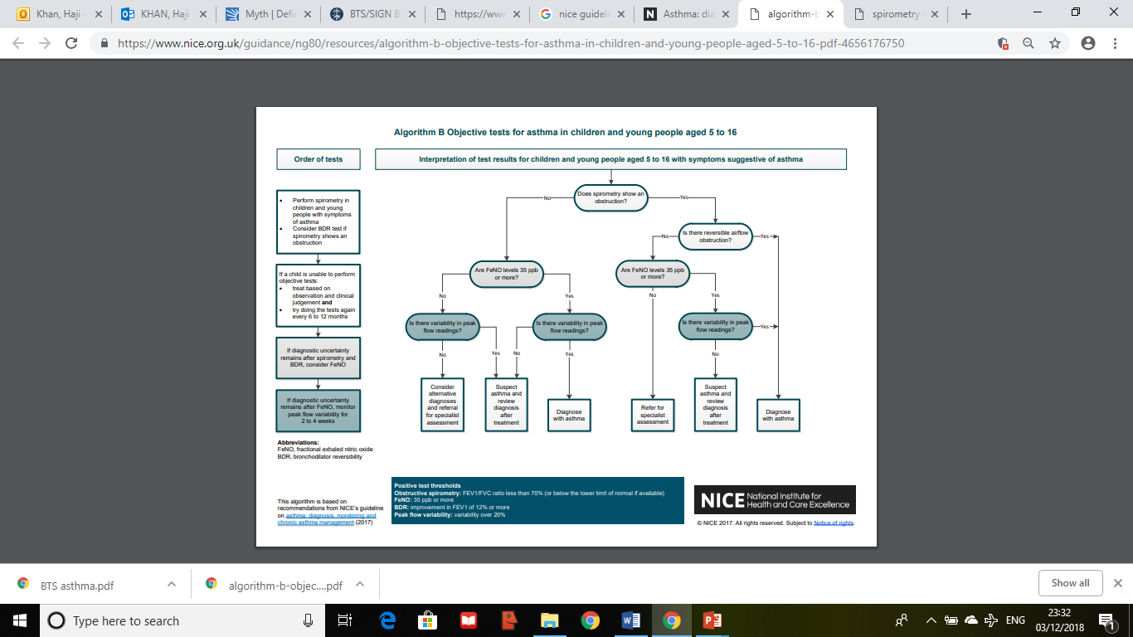

Link for the table (https://www.nice.org.uk/guidance/ng80/resources/algorithm-b-objective-tests-for-asthma-in-children-and-young-people-aged-5-to-16-pdf-4656176750)

**Triggers**

* Viral infections
* Allergens e.g. house dust mite, pollens
* Tobacco smoke
* Exercise
* Stress, laughter
* Cold air
* Medications e.g. beta-blockers, NSAIDs, aspirin

**PROBABILITY OF ASTHMA**

**High Probability**

Patients should be considered to have a high probability of having asthma if they have:

* A history of recurrent episodes of wheeze recorded by a health professional
* History of variable airflow obstruction
* A positive history of atopy
* No features to suggest an alternative diagnosis

**Low Probability**

In patients who do not have typical symptoms, or an alternative diagnosis is likely, then either investigate/ treat as the more likely alternative diagnosis or arrange further investigations to test for asthma.

**Intermediate Probability**

Patients have an intermediate probability of asthma if:

* Some, but not all, typical features are present, or
* Patients who do not respond well to a 6-8 weeks trial of ICS *(ensure compliance and inhaler technique first).*

In children who are old enough to perform PEFR, ask them to record a symptom and PEFR diary over 2-4 weeks and review with results.

Management options for children with an intermediate probability who are unable to perform PEFR:

* start initiation of ICS and review in 6-8 weeks
* if asymptomatic then adopt a “watchful waiting” approach.

**MANAGEMENT**

**Modifiable Risk Factors - Non-Pharmacological Therapy**

* Obesity
  + Offer weight-loss programmes where available. Encourage physical activity
* Smoking, including parental smoking
  + Refer to smoking cessation services
* Anxiety
  + Breathing exercise programmes may improve quality of life and reduce symptoms in some with asthma
* Confirmed food allergy
* Avoid NSAIDs if there is a clear history of exacerbation associated with its use.

*Note that the use of physical and chemical methods of reducing house dust mite burden in the house are not effective and should not be endorsed*

**Pharmacological Management - Stepwise approach**

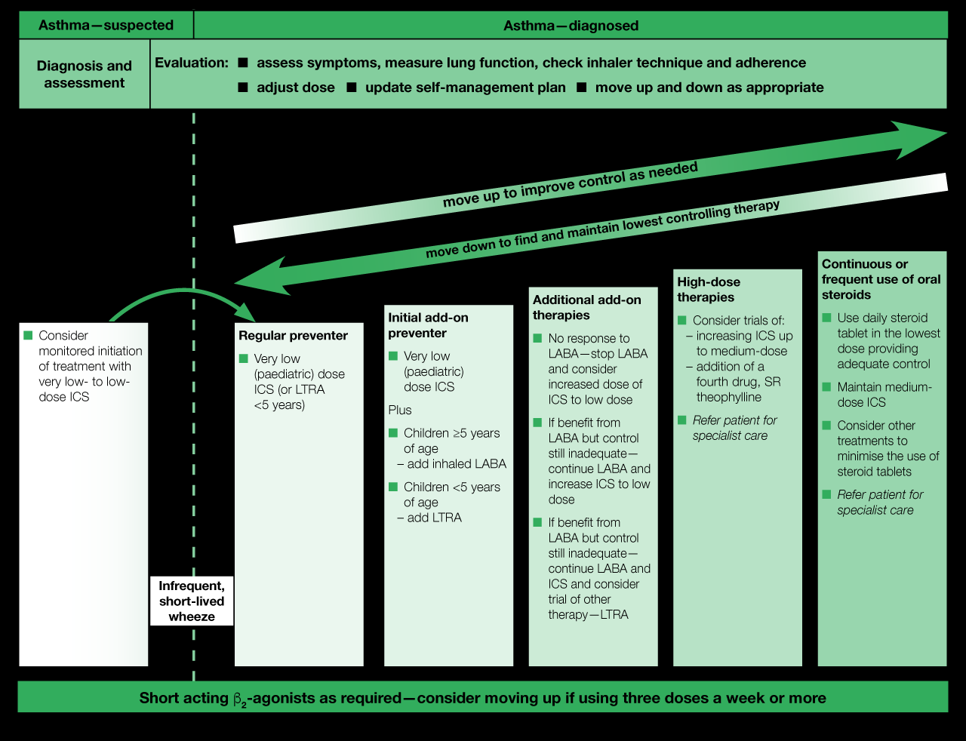

**STEP-WISE APPROACH**

**SABA as required**

Use in patients who fit the following profile:

* *Normal PEFR or FEV1*
* *Rarely symptomatic*
* *No nocturnal symptoms*
* *No exacerbations for over 1y*

**STEP 1 Very Low dose ICS**

or LTRA but this is less effective (consider in those <5 years)

**STEP 2 Very Low dose ICS/ LABA plus:**

Inhaled LABA if over 5 years

LRTA if under 5 years

**STEP 3 If no response to LABA**

Stop LABA, increase ICS to low dose

**If benefit from LABA but inadequate control**

Continue LABA and with increase ICS to low dose OR give a trial of LRTA

**STEP4 Refer to respiratory pediatrician**

Trial of:

Medium dose ICS

Or

Add in 4th Drug; SR Theophylline

**STEP 5 Under respiratory pediatrician only**

Low dose daily oral steroid, maintaining medium dose ICS

Anti-IgE *(SC omalizumab) in severe allergic asthma >6y*

Anti-IL5*(SC mepolizumab, SC benralizumab) >12y with**severe eosinophilic asthma*

**Stepping up**

If poor control despite 2-3 months of current treatment. CHECK:

* Is it the correct diagnosis?
* Check inhaler technique
* Check compliance
* Modifiable risk factors are adjusted where possible
* Co-morbid conditions are screened for and treated

**Stepping down**

If well controlled for 3 months + low risk for exacerbations

Complete control is defined by SIGN as:

* No exacerbations
* No need for rescue medication
* No nocturnal wakening due to asthma
* No day time symptoms
* No limitation of activity (including exercise)
* PEFR >80% best or predicted

Reduce ICS dose by 25-50% at 2-3 monthly intervals

Provide written asthma plan

Book a follow-up visit

**Categorization of inhaled corticosteroids**

|  |  |  |  |
| --- | --- | --- | --- |
|  | **Dose** | |  |
| **ICS** | **Very low dose** | **Low dose** | **Medium dose**# |
| **Pressurised metered dose inhalers (pMDI) with spacer** | | |  |
| **First line** | | |  |
| Clenil Modulite (**Beclometasone dipropionate)** | 50 micrograms two puffs twice a day | 100 micrograms two puffs twice a day | 200 micrograms two puffs twice a day |
| **Second line** | | |  |
| Fluticasone propionate | 50 micrograms one puff twice a day | 50 micrograms two puffs twice a day | 125 micrograms two puffs twice a day |
| Budesonide | 100 micrograms one puff twice a day | 100 micrograms two puffs twice a day  200 micrograms one puff twice a day | 200 micrograms two puffs twice a day  400 micrograms one puff twice a day |
| **Third line (Blue, licensed from 12 years old – see joint formulary on HERPC website** [**https://www.hey.nhs.uk/herpc/joint-formulary/**](https://www.hey.nhs.uk/herpc/joint-formulary/) **)** | | |  |
| Alvesco Aerosol inhaler (Ciclesonide) |  | 80 micrograms two puffs once a day | 160 micrograms two puffs once a day |
| **Combination inhalers** | | |  |
| **First line** | | |  |
| **Budesonide with formoterol** | | |  |
| Symbicort Turbohaler | 100/6 one puff twice a day | 100/6 two puffs twice a day  200/6 one puff twice a day |  |
| **Second line** | | |  |

|  |  |  |  |
| --- | --- | --- | --- |
| Fluticasone propionate with Salmeterol |  | 100/50 one puff twice a day |  |
| Fluticasone propionate with Salmeterol |  | 50/25 two puffs twice a day |  |

**Asthma Review Appointments**

* 1-3 months after starting treatment
* Then every 3-12 months depending on level of control, response to treatment and skills at self-management
* Within 1 week following an exacerbation
* Check inhaler technique at every opportunity
* Smoking cessation advice (if applicable)
* Check compliance
* At least 50% of patients do not take their controller medications as prescribed
* Check with patient how many days a week they miss a dose
* Check dispensing records
* Explore attitudes and beliefs about asthma and the treatment

**Written Asthma Action Plans**

Personalized action plans have been shown to improve outcomes for asthmatics. They should be given to all patient’s carers so they know how to recognize worsening asthma and respond appropriately. At each review appointment, or following an acute exacerbation, the plan should be reviewed.

Action plan resources can be downloaded: www.asthma.org.uk/control

**Alternative Diagnoses**

Many alternative diagnoses have features which may overlap with asthma. Consideration should be given to other possibilities such as; recurrent viral infections, gastro-oesophageal reflux, post-nasal drip, vocal cord dysfunction, amongst others.

**Referral to specialist care should be done in children with the following features**

* Step four of Asthma management
* Failure to thrive
* Abnormal clinical findings (such as stridor, focal chest signs, dysphagia)
* Symptoms present from birth
* Excessive vomiting
* Nasal polyps
* Severe respiratory infection(s)
* Persistent productive cough
* Family history of unusual respiratory disease
* Significant care-giver anxiety
* Severe or life-threatening exacerbation

**References**

1. Global Initiative for Asthma, Pocket Guide for Asthma Management and Prevention (for adults and children older than 5 years) Updated 2018
2. <https://patient.info/doctor/diagnosing-childhood-asthma-in-primary-care#nav-2>
3. British Guideline on the Management of Asthma, Quick Reference Guide, British Thoracic Society Scottish Intercollegiate Guidelines Network (September 2016)
4. NICE
5. <https://www.nice.org.uk/guidance/dg12> Measuring fractional exhaled nitric oxide concentration in asthma: NIOX MINO, NIOX VERO and NObreath (April 2014)
6. Price, D Rigazio, A, Campbell, J Bleecker, E Hillyer, E Kerhof, M Pavord, I Blood eosinophil count and prospective annual asthma disease burden: a UK Cohort Study The Lancet Respiratory Medicine, VOLUME 3, ISSUE 11, P849-858, NOVEMBER 01, 2015
7. [www.asthma.org.uk/control](http://www.asthma.org.uk/control)
8. [www.ginasthma.org](http://www.ginasthma.org)
9. [www.admit-inhalers.org](http://www.admit-inhalers.org)
10. Kamps AWA, Roorda RJ, Brand PLP Peak flow diaries in childhood asthma are unreliable Thorax 2001;56:180-182.
11. Johnston, Anderson, H Patel, s Variability of peak flow in wheezy children Thorax 1984;39:583-587

**Key Abbreviations**

PEFR Peak Expiratory flow rate, a person's maximum speed of expiration, as measured with a peak flow meter

FEV1 Forced Expiratory Volume, is the maximal amount of air you can forcefully exhale in one second

FVC Forced vital capacity measurement, shows the amount of air a person can forcefully and quickly exhale after taking a deep breath

The FEV1/FVC ratio, also called Tiffeneau-Pinelli index, is a calculated ratio used in the diagnosis of obstructive and restrictive lung disease.

ICS Inhaled CorticoSteriods

LRTA Leukotriene Receptor Antagonists

SABA Short-acting beta agonist

LABA Long-acting beta2 agonist

LAMA long acting muscarinic antagonist