- Register your NHS Care Identity profile with Gateway® by clicking https://nww.gateway.accenda.co.uk/register
- You will receive a “Welcome to Gateway” email once we approve your registration request.
- Run the “Gateway” app from the desktop icon; it looks like this:
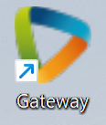
Tip: If you do not have the Gateway icon on your desktop, you can use the “Software Self Service” app to install:
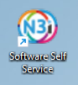
Find the “Accenda Referral Gateway” application, then click Install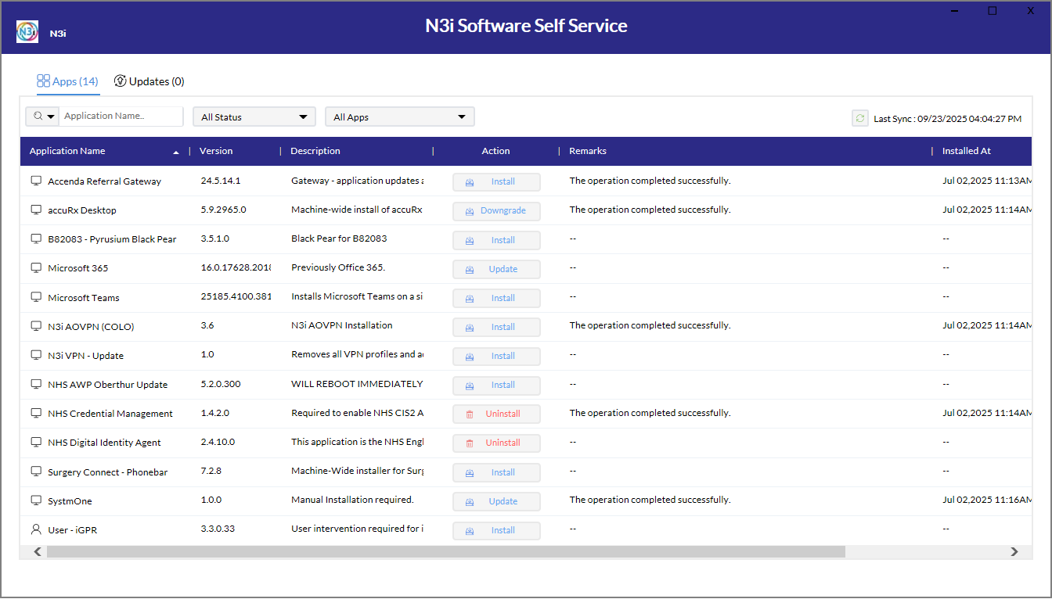

- On first use, you will be prompted to Install: 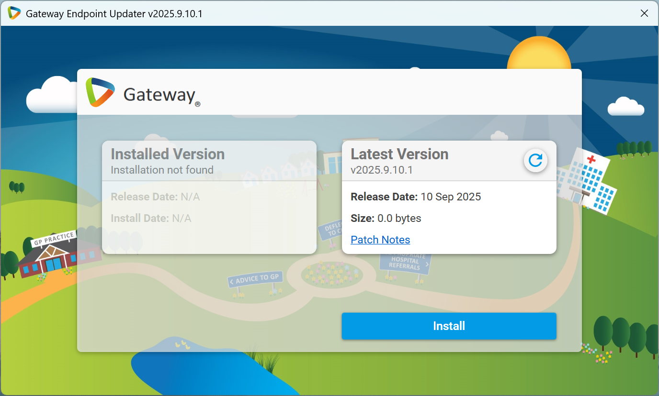
- Click Smartcard Login:
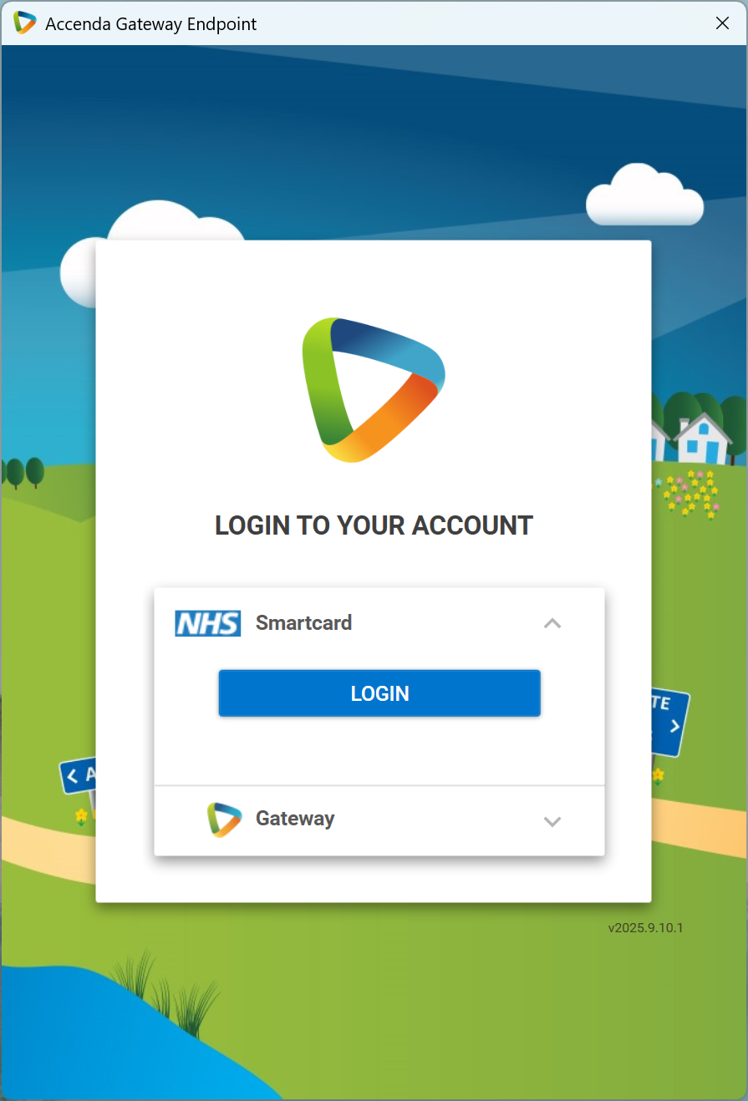
- Check the “Always allow…” tick-box, then click Open in the browser prompt:
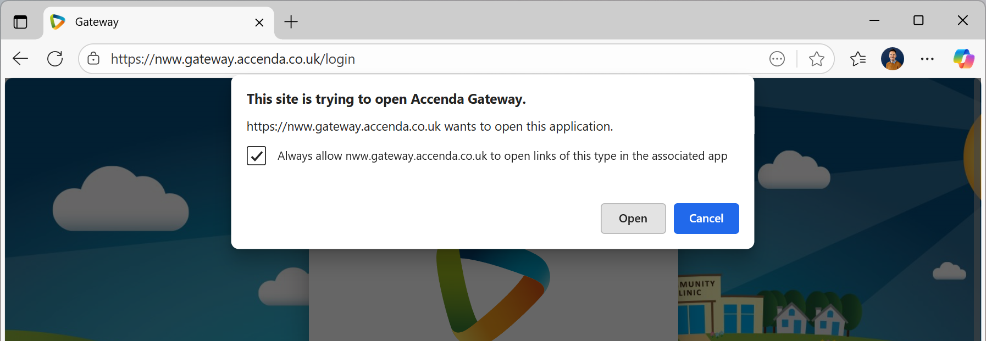
- Click the first ‘colourful triangle’ icon in the Gateway floating toolbar for it to establish its pairing connection with SystmOne
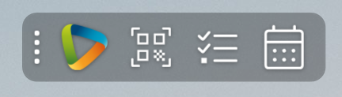
- The SystmOne icon will then flash on the Windows taskbar. Click this to show the Approve/Deny prompt, click Approve:
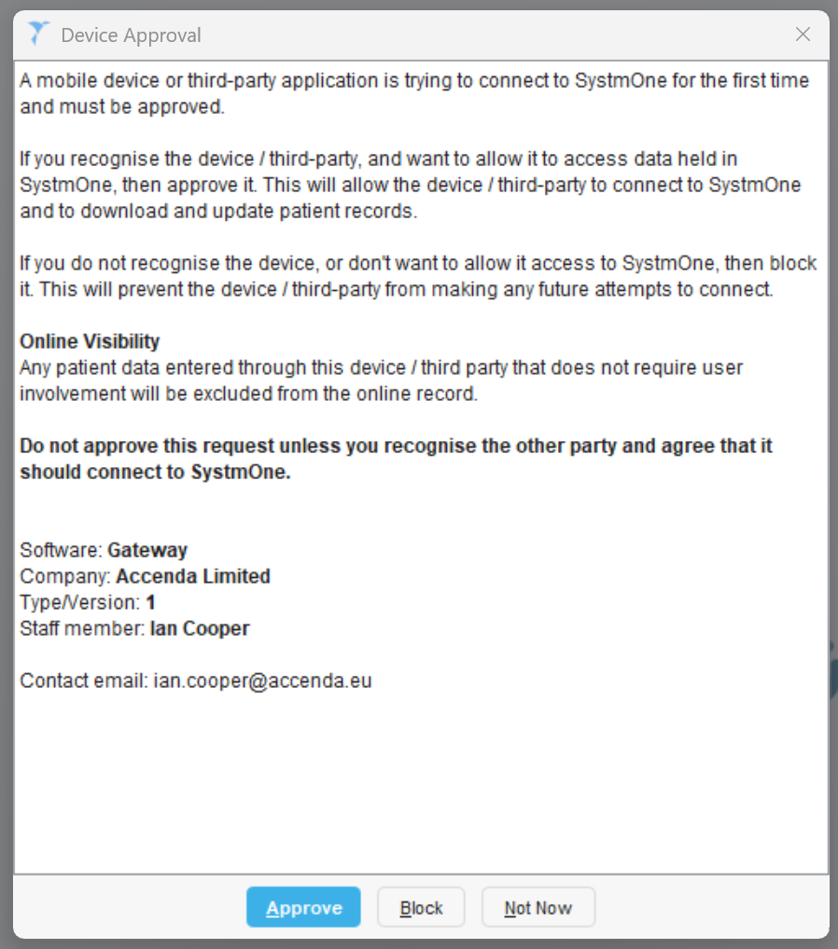
- Gateway® has now been successfully configured at your practice. The Gateway toolbar will now automatically start with Windows.

If you need any support with these steps, you can phone Accenda Support on 0161 274 9730 (8am – 6pm, Mon – Fri) or email support@accenda.co.uk.

