One person per practice with permissions to access “Organisation Configuration” and “EMAS Manager” is needed to follow the below steps configure and active the Gateway integration with EMIS Web.

This process should only take approx. 5 minutes to complete, you can also phone us on 0161 274 9730 and we’ll remote connect to assist you if needed.

- Step 1: Creating a GATEWAY user in EMIS
- Step 2: Enable Partner API Access for the GATEWAY user
- Step 3: Confirm you’ve completed these steps

Creating a GATEWAY user in EMIS

- Click EMIS > Configuration > Organisation Configuration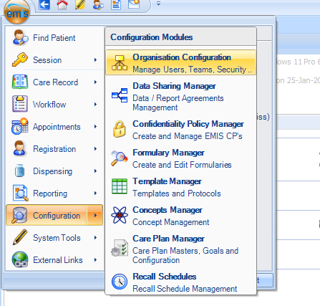
- Click Add > Add New User
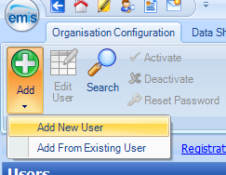
- Complete the User details tab with the following details:
- First name: Integration
- Last name: Gateway
- Email address: support@accenda.co.uk
- Username: GATEWAY
- Password: <this can be anything – we do not need to know this>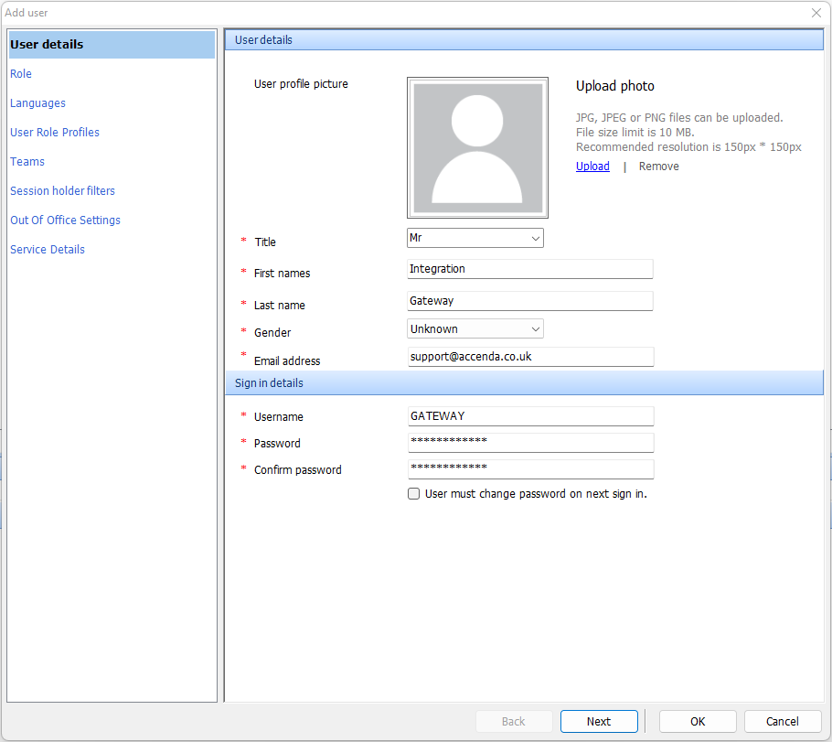
- Complete the Role tab - any values can be entered (Appointment Session Holder, Consulter and Authorise Prescriptions can all be set to No/None).

- Complete the User Role Profiles tab, selecting RBAC Role: NHS Role Profile > Systems Support
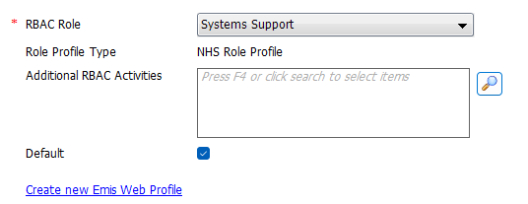
- Click the icon to select the RBAC Activities. You can search for each of the following roles by entering the code (i.e. “B0820”). To add, double click the appropriate item to ensure the role appears in the Selected Items:
Roles to be added:
- B0820 “View Patient Demographics”
- B0360 “View Detailed Health Records”
- B0380 “Perform Detailed Health Record”
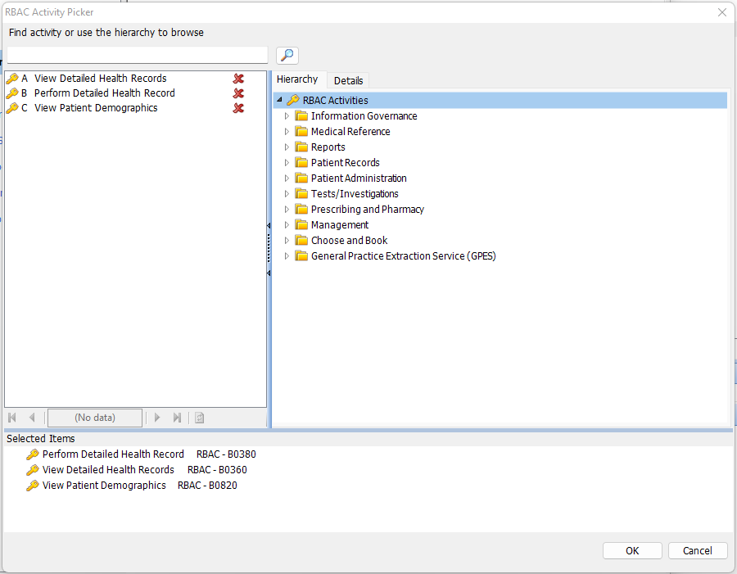
- Once all three roles have been added, click OK
- This section should now look like this:
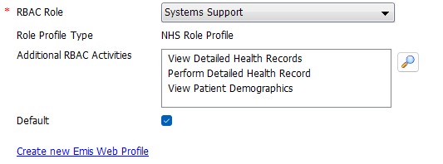
- Click OK to complete the ‘add user’ process.
- The new GATEWAY user has now been successfully created.

Enable Partner API Access for the GATEWAY user
- Click EMIS > System Tools > EMAS Manager
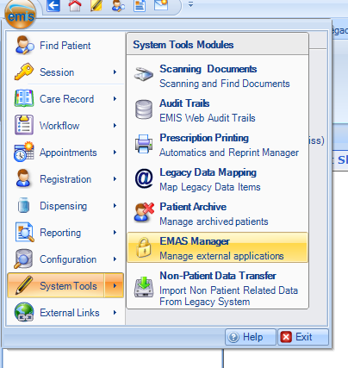
- Within the EMAS Manager, please select the Partner API option in the bottom-left
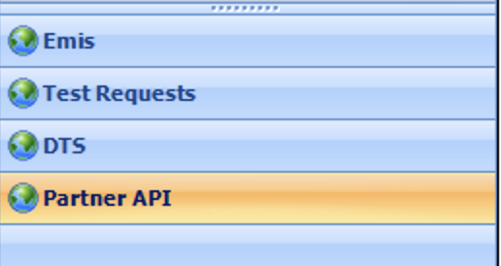
- Select “Gateway” within the list or partner products
- Click Edit Users from the menu bar
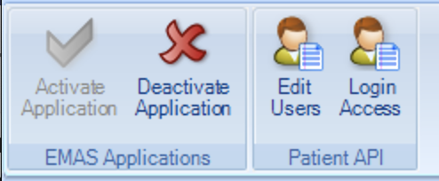
- Find the newly created GATEWAY user, then select the checkbox next to this entry
- A User Password box will appear. Please set any password, you will not need to remember this.
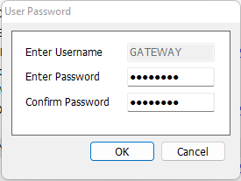
- Click OK, then OK again to return to the Product List
- Again, with the “Gateway” product still selected, click Login Access from the menu bar
- Find the GATEWAY user, then select the checkboxes for Auto Login and Allow Login. Then click OK.
- The Partner API has now been configured.

Confirmation
Once the new GATEWAY user has been created and the user has been granted API access, please could you click this link to let our team know. Confirming the steps are now complete.

Further assistance and Support
If you need any help completing these steps, please Click here for assistance or phone us on 0161 274 9730 and a member of the team will help you.

